Name: ____________________ Table #: _____ Period: _______ Date: _____

**5.2A Proportions_Classwork**

*Objective: use equivalent ratios to determine whether two ratios form a proportion; use the Cross Products Property to determine whether two ratios form a proportion. (CC.SS.7.RP.2a MP3: Construct Viable Argument)*

*HW: 5.2A worksheet*

|  |  |  |  |  |
| --- | --- | --- | --- | --- |
| **REVIEW:**   |  |  | | --- | --- | | 1. *Are the fractions equivalent? Explain.* | 1. *Are the fractions equivalent? Explain.* | |  |  | |

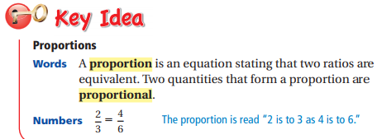

Tell whether the ratios form a proportion (equivalent).

1.  2.  3.  4. 

***Tell whether x and y are in a proportional relationship.***

***A table has a proportional relationship when…***

|  |  |  |
| --- | --- | --- |
| a. | b. | |
| c. | d. |
| e. | f. |