Name: ___________________________ Table #: _______ Period: ______ Date: ______
5.2C Graphing Proportional Relationships_Classwork
Objective: use graphs to determine whether two ratios form a proportion; interpret graphs of proportional relationships. CC.SS.7.RP.2a, 2b, 2d.
Determining PROPORTIONAL (Direct Variation) | Determining NON-PROPORTIONAL
Table  Graph 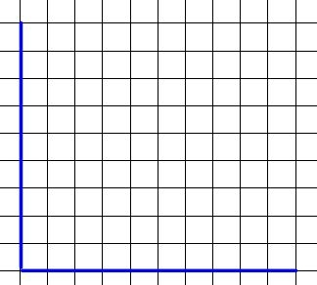 | Table  Graph

Use a graph to tell whether x and y are in a proportional relationship.
Example 1.  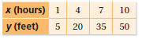 | Example 2.  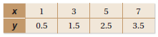
Interpreting the Graph of a Proportional Relationship
Example 3.
The graph shows that the distance traveled by the Mars Rover Curiosity is proportional to the time traveled. Interpret each plotted point in the graph.
(0, 0) =

(1, 1.5) =

(3, 4.5) =

Example 4.
The graph shows that the earning in dollars is proportional to the hours Sally worked. Interpret each plotted point in the graph.
(0, 0) =

(1, 15) =

(4, 60) =

Example 5.
The graph shows that the height of the hot air balloon is proportional to the seconds it is in the air. Interpret each plotted point in the graph.
(0, 0) =

(1, 5) =

(6, 30) =

TEACHER’S NOTES
