Name: ___________________ Table#: ______ Period: ______ Date: ______
5.5B Slopes_Classwork
Objective: Derive slope using graph and table (CC.SS.7.RP.2b) Hw: 5.5B HW
WATCH “Slope Dude” https://www.youtube.com/watch?v=avS6C6_kvXM
POSITIVE SLOPE  m = positive value  the line rises from left to right | NEGATIVE SLOPE  m = negative value  the line falls from left to right. | SLOPE OF ZERO  m = zero value  the line is horizontal | UNDEFINED SLOPE  m = no value  the line is vertical

Use $\frac{rise}{run}$ to find the slope of the line.

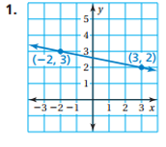  m =  description: | 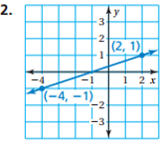  m =  description: | 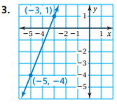  m =  description:

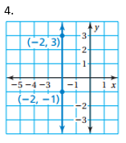  m =  description: | 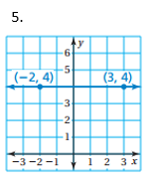  m =  description:
Use the table to find the slope (constant rate of change)
6.  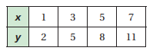  m = description: | 7.  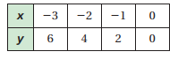  m = description:

1.  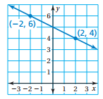 m =  description: | 2.  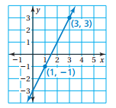 m =  description:

3. Use the table to find the slope (constant rate of change)

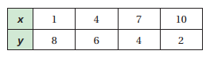

m = description:

4.  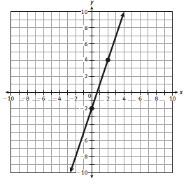 m =  description: | 5.  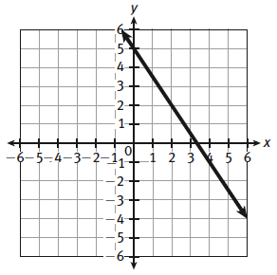 m =  description:
6.  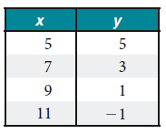 m =  description: | 7.  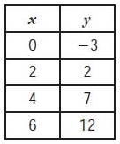 m =  description:

