Name: _______________________________ Table #: ______Period: ____ Date: ____
5.6A Direct Variation_Classwork
Ojbective: identify direct variation from graphs or tables. CC.SS.7.RP.2a/b/c/d
HW: 5..6A worksheet

Examples of Direct Variation

PART 1 GRAPHS: Are the following graphs examples of direct variation? If not, then explain why.

1. 2. 3.
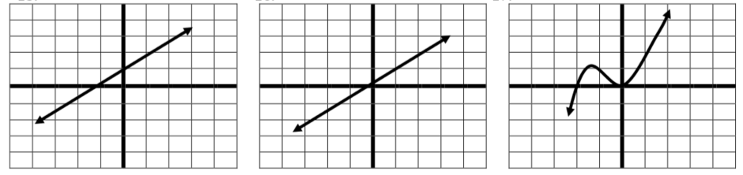

______________________________ ____________________________ _____________________________

______________________________ ____________________________ _____________________________

PART 2 TABLES: Are the following tables examples of direct variation? Is so state the constant of variation (k). Hint: Makes sure that $\frac{y}{x}$ is the same for all points.

1. 2. 3. 4.
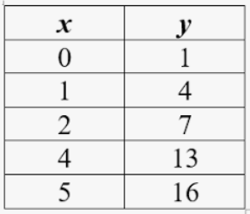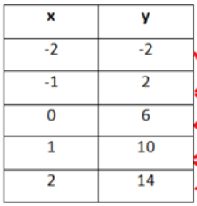

BACK
PRACTICE PROBLEMS

DIRECTION: Tell whether each of the following represents direct variation. If yes, state the constant of variation.
1. 2. 3.
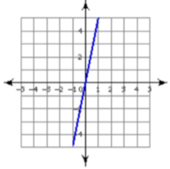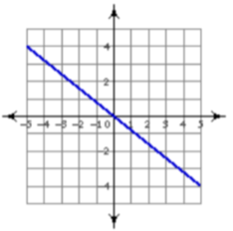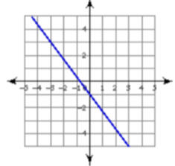

DIRECTION: Tell whether each of the following represents direct variation. If yes, state the constant of variation
1. 2. 3.
