Name: _________________________ Table #: __________ Period: ________ Date: ______
6.0A Graphing Linear Equations Using X/Y Tables_Classwork
Objective: graph linear equations using x/y tables. CC.SS.8.EE.5
HW: 6.0A worksheet

An ordered pair is a solution of an equation when _____________________________________________.

Step 1: | Plug in the value for x and y into the equation and simplify.
Step 2: | If the values are equal to each other, then the ordered pair is a solution of the equation. If the values are not equal to each other, then the ordered pair is NOT a solution of the equation.

Helpful videos: https://www.youtube.com/watch?v=3f1vYgM0qzo

Part 1: Tell whether the ordered pair is a solution of the equation. Just substitute the given x and y to see if the equation “works”. Write “solution” if it works and “not solution” if it doesn’t.
1.  $$y=2x+3;(4, 11)$$ | 2.  $$7x-y=2;(1, -2)$$ | 3.  $$y=-2-2x;(-1, 0)$$

Helpful videos: https://www.youtube.com/watch?v=9G4vmVvqCwQ

Part 2: Graph the linear equations a table of values.
1.  $$y=x-3$$  x x – 3 y (x, y)  -5  0  4 | 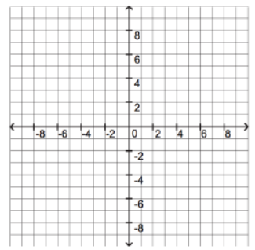
2.
$$y=-x+4$$

x | -x + 4 | y | (x, y)
-3

0

7

3.
$$y=3x-1$$

x | $$3x-1$$ | y | (x, y)
-2

0

2

4.  x y  2 -2  2 0  2 5 | What do you notice about the values from the table and the graph? | 5.  x y  -2 2  0 2  5 2 | What do you notice about the values from the table and the graph?

