Name: ________________________ Table #: ______ Period: _______________ Date: ________
6.1A NOTES – Relations and Functions
Objective: define relations and functions; determine whether relations are functions; describe patterns in mapping diagrams. CC.SS.8.F.1
HW: textbook- 6.1A pg 246_#3-11 odd, 12-17 all, 19-22 all. SCROLL DOWN WHEN DOING BIM. ONLY ONE CHECK.
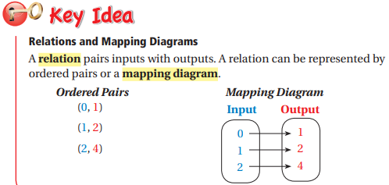
- The ____________________ is the set of x values. It can also be called inputs or independent variable.

- The ___________________ is the set of y values. It can also be called outputs or dependent variable.

- A relation may be viewed as ordered pairs, mapping diagram, table, graph, equation, or written in sentences.

Mapping Diagram  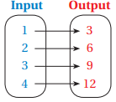 | Ordered Pairs | Table  X Y
Graph | Equation | Written sentence

EXAMPLE 1: Express the relation {(-4, -1), (-1, 3), (1, -4), (2, -3), (4, 3)} as a table, a graph, and a mapping. Then, state the domain and range of the relation.
X Y  DOMAIN: _____________________  RANGE: ______________________ | 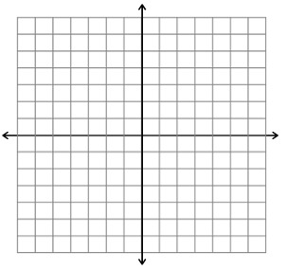 | 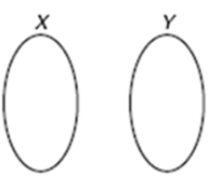
Determine when a relation is a function: A relation that pairs each input with EXACTLY ONE output is a function.
- Focus on the x-coordinates, when given a relation. If the set of ordered pairs have different x-coordinates, it is a function.
- If the set of ordered pairs have same x-coordinates, it is not a function.
- Y-coordinates have no effect of determining functions.

EXAMPLE 2: List the ordered pairs shown in the mapping diagram.

EXAMPLE 3: Determining if a Relation is a Function Using Ordered Pairs.

- {(7, 4), (6, 3), (5, 2)}  Function? ____________  Explain: | - {(15, 0), (15, -2)}  Function? ____________  Explain: | - {(0,1), (2, 1), (0, 3)}  Function? ____________  Explain:

EXAMPLE 4: Determining if a Relation is a Function Using Tables.

A)  Function? ____________  Explain: | B)  Function? ____________  Explain: | C)  Function? ____________  Explain:

EXAMPLE 5: Determining if a Relation is a Function Using Graphs.

A)  Function? ____________  Explain: | B)  Function? ____________  Explain: | C)  Function? ____________  Explain:

EXAMPLE 6: Determining if a Relation is a Function Using Mapping Diagrams.

A)  Function? ____________  Explain: | B)  Function? ____________  Explain: | C)  Function? ____________  Explain:

