Name: _______________ Table #: ______ Period: _______ Date: ______
6.1B NOTES – Graphing Linear Equations

Objective: Graph linear equations using a table. Understand that lines represent solutions of linear equations (CCSS: 8.EE.5) HW: 6.1B worksheet

*******WARM-UP: Solve for y to get in the form of y = mx + b
1. -2x + y = 7 | 2. 3x – y = 1 | 3. $y=\frac{4}{5}x$  x y (x,y)  5  0  -5

For the graphs below, remember to label your x- & y-axis and use equal intervals
- You have $100 in your savings account  - Complete the table below using  y=20x + 100  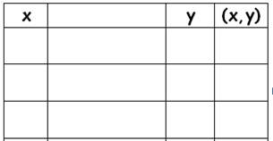  - Graph the linear equation y = 20x + 100 that represents the balance in your account.  - When will you have $180 in your account? | and plan to deposit $20 each month.  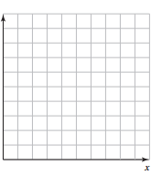
- The equation y=3x+3 represents the  that weighs x pounds.  - Complete the table below using  y=3x+3  - Graph the linear equation  - Use the equation to find exactly how much it costs to mail the package if it is 1.126 lbs. | cost y (in dollars) of mailing a package
For the equations below, choose three x-values, complete the tables, and make the graphs below.
If the 3 points do not connect to make a straight line, review your calculations on the table and/or review how you graphed the ordered pair.
- y = $-2x+2$ | 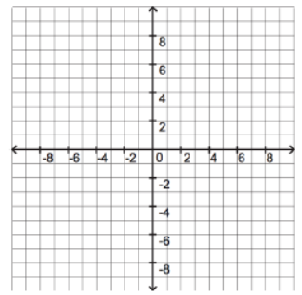
- $y= \frac{1}{3}x$

- y = -4  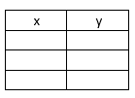 |  | - x = 5

