Name: _____________________________ Table#____ Period ____ Date ______________
6.1B HW
1. y = -5x  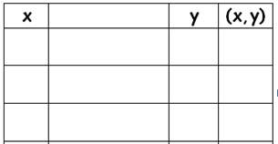 | 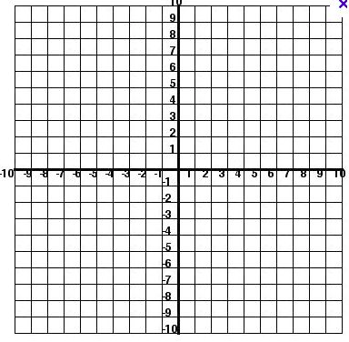
2. $y= \frac{1}{4}x$
3. y = x – 3
4. x = -3  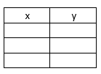 | 5. y = 4
6. $y= 3x-1$
7. The equation y = 2x + 3 represents the  cost y (in dollars) of mailing a package  that weighs x pounds.  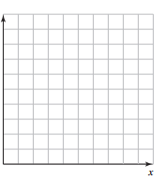 | - Graph the equation  - Use the graph to estimate how much it costs to mail the package.  - Use the equation to find out exactly how much it costs to mail the package.  THE PACKAGE $↓$
- Graph the equation 5x + 2y = 4 by  - Solving for y  - Picking 3 x-values and completing the table  - Graphing the ordered pairs | - Solve for y: 5x + 2y = 4

