Name: _____________________________ Table#____ Period ____ Date ______________
6.1B HOMEWORK
1. y = -5x  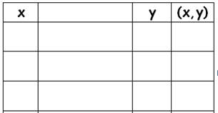 | 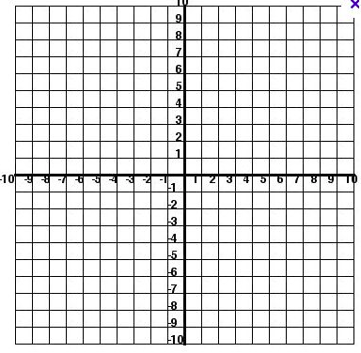
2. $y= \frac{1}{4}x$
3. y = x – 3
4. x = -3  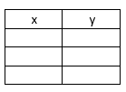 | 5. y = 4
BACK
6. $y= 3x-1$
7. The equation y = 2x + 3 represents the  cost y (in dollars) of mailing a package  that weighs x pounds.  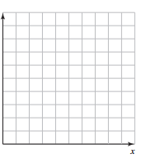 | - Graph the equation  - Use the graph to estimate how much it costs to mail the package.  - Use the equation to find out exactly how much it costs to mail the package.  THE PACKAGE $↓$
- Graph the equation 2 x +y = 3 by  - Solve for y  - Pick 3 x-values and complete the table  - Graph the ordered pairs | - Solve for y: 2x + y = 3

