Name: ______________________________ Table #: ___________Period: _____ Date: ____

6.2A Comparing and Ordering Values_Classwork

Objective: write percents as decimals, write decimals as percents, and solve real-life problems.
CC.SS.7.EE.3 and MP4 Model and Mathematics
HW: 6.2A worksheet
REVIEW
- Complete the table below | Review Notes:  Convert fraction into decimal and percent  $$1=$$  $$\frac{2}{3}=$$  $$\frac{12}{5}=$$  $$3\frac{1}{6}=$$

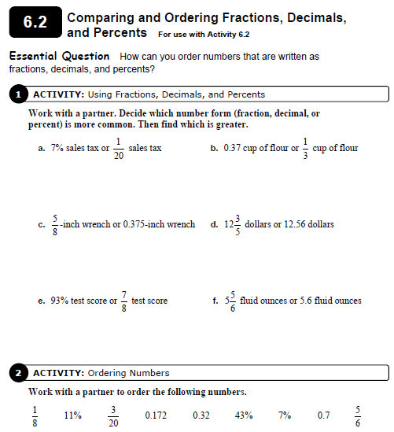

Example 1
You, your sister, and a friend each take the same number of shots at a soccer goal. You make 72% of your shots, your sister makes $\frac{19}{25}$ of her shots, and your friend makes 0.67 of his shots.

- Who made the fewest shots? | - Order from least to greatest

Example 2
You make 75% of your shots, your sister makes $\frac{13}{20}$ of her shots, and your friend makes 0.7 of his shots.

- Who made the most shots? | - Order from least to greatest

Put the values in order from least to greatest

ANSWER: _____________________________________________________________________

