Name: ____________________________________ Table #: ______ Period: ______ Date: _____
6.2A Representations of Functions_Classwork
Objective: Write function rules. Use input-output tables to represent functions. Use graphs to represent functions. (CCSS: 8.F.1)
HW: (6.2) p. 253 #2, 4-6, 7-23 odd, 25, 26 (Solutions on p. A28) – use handout

Warm Up
1.  Solve for y. $2x-y=6$ | 2.  One solution, many solutions, or no solutions. $4x+2=2(x+1)$

Read p. 250-2, particularly Examples 1 – 4. Fill in the blanks and do the On Your Own Problems
Also pay attention to the FIVE WAYS TO REPRESENT AN EQUATION
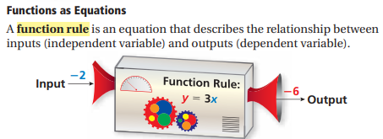 | An independent variable represents a quantity that  ___________________________________________  A dependent variable ________________ on the  ___________________________________________

Writing Function Rules -- (1) WORDS & (2) EQUATIONS
Example 1: Write a function rule for “The output is one-fourth of the input.” | Example 2: Write a function rule for “The output is three less than the input.”
- Write a function rule for “the output is twice the input.” | - Write a function rule for “The output is 4 greater than one-third of the input.”

DIRECTIONS: Evaluating a Function. Find the value of y for the given value of x.
3. y = 4x – 1; x = 5 | 4. y = 10x; x = 5 | 5. y = 7 – 3x; x = 5
DIRECTIONS: (3) GRAPHS
Pick your own x values. HINT: If the coefficient is a whole number, then pick small x values such as -2, -1, 0, -1 , 2. If the coefficient is a fraction, then the pick x values that are multiple of the coefficient.
6. Graph $y = 2x + 1$  x $$2x + 1$$ (x, y)  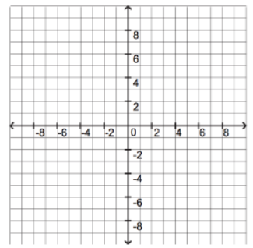 | 7. Graph $y = \frac{x}{3}$  x $$\frac{x}{3}$$ (x, y) | 8. y = $\frac{1}{2}x-1$  x $$\frac{1}{2}x-1$$ (x, y)

Real Life Application—(4) TABLES & (5) MAPPING DIAGRAMS
9. The distance m in miles traveled by a car is 35 times greater than the number of gallons g of gasoline
used by the car. Graph a function that describes the relationship between g and m.
Then make a mapping diagram of the situation.

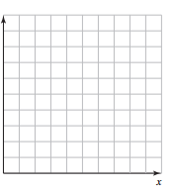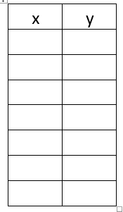

Name: ________________________________________ Table# ___ Per ___ Date ______________
6.2A HW TEXTBOOK

HW: (6.2) p. 253 #2, 4 – 6, 7 – 23 odd, 25, 26 (HINT FOR #2: Read “Summary” on p. 252)

2. ____________________, ______________________, _____________________________,
____________________, _______________________
Find the slope and pick one of the points to find the equation in y = mx + b (See Warm Up #1 from 6.2 Notes)
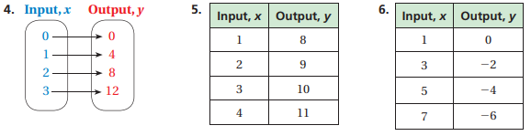

7. __________________________________ 9. __________________________________

11. __________________________________ 13. _________________________________

15. __________________________________ 17. _________________________________
19. 21. 23.

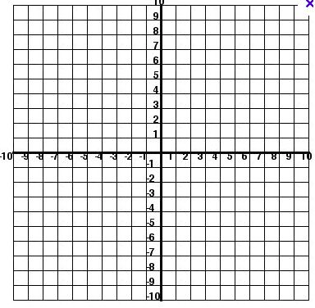
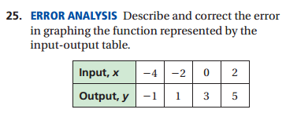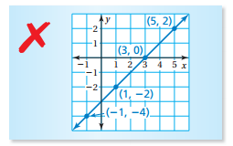

26.

