Name: ______________________________ Table #: ___________Period: _____ Date: ____

6.2B Comparing and Ordering Values_Classwork
Objective: write percents as decimals, write decimals as percents, and solve real-life problems.
CC.SS.7.EE.3 and MP4 Model and Mathematics

REVIEW
Fill in the blanks to show the equivalent fractions, decimal and percent values. Round answers to the nearest thousandth. Simplify fractions.
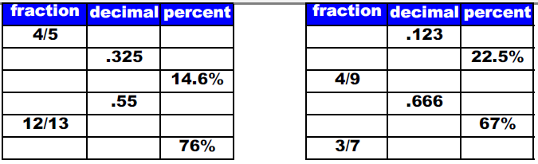

- Place these numbers in order from smallest to largest. Then place it in a number line.

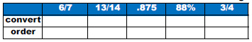

- Place these numbers in order from smallest to largest. Then place it in a number line.

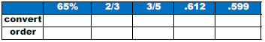

WE TRY!
Example 1:
On the last math test, Murphy got an 82%. Ralph got 20 of the 25 question correct. Who had the higher grade?

Example 2:
Twenty percent of the students in Ms. Cay like chocolate. Another 0.35 like strawberry, and the rest of the class like vanilla. Write the number of students like vanilla as a fraction, decimal, and percent.

YOU TRY!
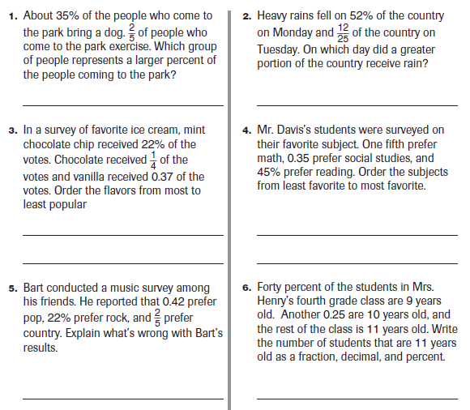
http://www.mastermath.info/index.php?option=com_content&view=article&id=43%3Acompare-and-order-fractions-decimals-and-percents-&catid=4%3A62&Itemid=26

