Name: ___________________ Table#: ______ Period: ______ Date: ______
6.2B Slope of a Line_Classwork

Objective: Derive slope using graph and table (CCSS: 8.EE.6)

WATCH “Slope Dude” https://www.youtube.com/watch?v=avS6C6_kvXM
POSITIVE SLOPE  m = positive value  the line rises from left to right | NEGATIVE SLOPE  m = negative value  the line falls from left to right. | SLOPE OF ZERO  m = zero value  the line is horizontal | UNDEFINED SLOPE  m = no value  the line is vertical

GRAPHS
1. a) Describe the slope. ____________________  b) Then find the slope of the line.  m =  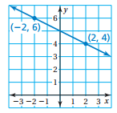 | 2. a) Describe the slope. ____________________  b) Then find the slope of the line.  m =  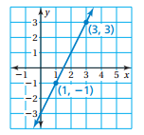
3. a) Describe the slope. ____________________  b) Then find the slope of the line.  m =  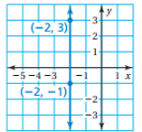 | 4. a) Describe the slope. ____________________  b) Then find the slope of the line.  m =  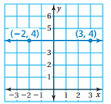
TABLES
5. Use the table to find the slope (constant rate of change)
a) Describe the slope. ____________________
b) Then find the slope of the line.
m =

6. Use the table to find the slope (constant rate of change)
x y  -2 4  -1 4  0 4  1 4 | a) Describe the slope. ____________________  b) Then find the slope of the line.  m =

7. Use the table to find the slope (constant rate of change)
a) Describe the slope. ____________________
b) Then find the slope of the line.
m =

Use EQUATION to find the slope. Circle the slope and write it out. y = mx + b
- $y=3x+5$  m = ________ b = ________  - $y=-5x-7$  m = ________ b = ________  - $y=-x$  m = ________ b = ________  - $y=2x+5$  m = ________ b = ________ | - $y=x$  m = ________ b = ________  - $y=-3x$  m = ________ b = ________  - $y=\frac{1}{5}x-2$  m = ________ b = ________  - $y=-\frac{1}{4}x-1$  m = ________ b = ________

CLASSWORK. Complete the following problems below.
Use $\frac{rise}{run}$ to find the slope of the line.

7.  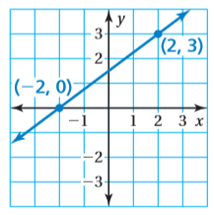 m = | 8.  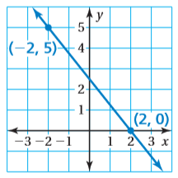 m = | 9.  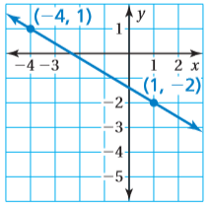 m =
10.  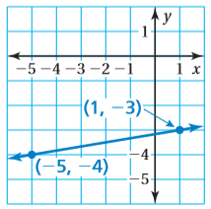 m = | 21.  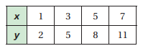  m = | 22.  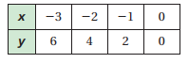  m =
23.  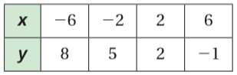  m = | 24.  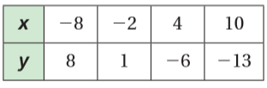  m = | 33.  Do the points A(-2,-1), B (1, 5), and C(4, 11) lies on the same line? Explain.

