Name: _____________________________ Table #: ________Period: ______Date: ______
6.3A NOTES – Linear Functions
HW: (6.3A) p. 261 #5 – 10, 20 - 23 (Solutions on p. A29)
Objective: Interpret y = mx + b as defining a linear function. Writing linear functions from tables. CCSS: 8.F.3

A LINEAR FUNCTION can be written in the form y = mx + b, where m is the slope and b is the y-intercept.

Writing a Linear Function Using a Graph  To find slope or “m” $→$ $\frac{rise}{run}$  To find y-intercept or “b” $→$ IT IS THE POINT THAT LIES ON THE Y-AXIS | EXAMPLE 2: Writing a Linear Function Using a Table  To find slope or “m” $→$ $\frac{change in y}{change in x}$  To find y-intercept or “b” $→$ WHEN x = 0,  THE “y value” IS THE Y-INTERCEPT.  FOR EXAMPLE, (0,2) THE Y-INT. OR b is 2
EXAMPLE 1: Use the graph to write a linear function that relates y to x.  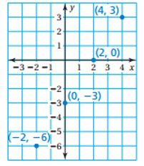 | EXAMPLE 2: Use the table to write a linear function that relates y to x.  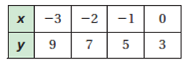
EXAMPLE 3: Use the graph to write a linear function that relates y to x.  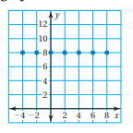 | EXAMPLE 4: Use the table to write a linear function that relates y to x.  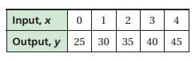
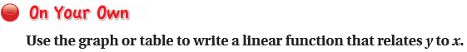
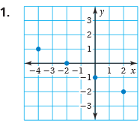 | 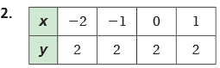
3.  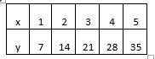 | 4.  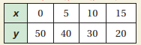
5.  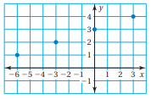 | 6.  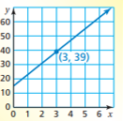
7.  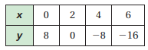 | 8.  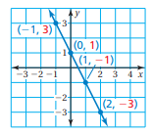

9. MOVIES: The table shows the cost y (in dollars) of renting x movies.
- The independent variable is ___________________________

The dependent variable is ____________________________

- Write a linear function that relates y to x. Interpert the slope.

Linear function: _____________________________________

The slope in the linear function means: __________________

- Graph the linear function

- How much does it cost to rent 3 movies?

It costs _________ to rent 3 movies.

Took this off so we could include “MOVIE” question

WARM UP

1. Graph y = -3  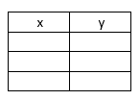  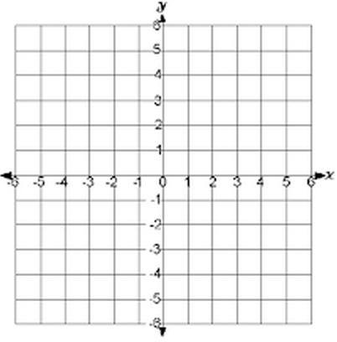 | 2. Graph x = 4 | 3. Graph $y= \frac{1}{2}x+1$  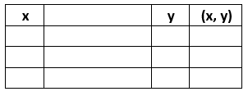

x | 1 | 2 | 3 | 4 | 5
y | 7 | 14 | 21 | 28 | 35

