Name: _____________________________ Table #: ________Period: ______Date: ______
6.3A Linear Functions_Classwork
Objective: Interpret y = mx + b as defining a linear function. Writing linear functions from tables. CCSS: 8.F.3
HW: (6.3A) p. 261 #4 – 10, 20 - 23 (Solutions on p. A29)

A LINEAR FUNCTION can be written in the form y = mx + b, where m is the slope and b is the y-intercept.
Writing a Linear Function Using a Graph  - How is the slope determined from the graph?  FIND $\frac{rise}{run}$  - How is the y-intercept determined from the graph?  IT IS THE POINT THAT LIES ON THE Y-AXIS | EXAMPLE 2: Writing a Linear Function Using a Table  - How is the slope determined from the table?  FIND $\frac{change in y}{change in x}$  - How is the y-intercept determined from the table?  WHEN x = 0, THE “y” IS THE Y-INTERCEPT.  FOR EXAMPLE, (0,2) THE Y-INT. OR b is 2
EXAMPLE 1: Use the graph to write a linear function that relates y to x.  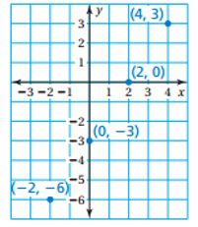 | EXAMPLE 2: Use the table to write a linear function that relates y to x.  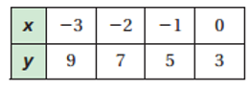
EXAMPLE 3: Use the graph to write a linear function that relates y to x.  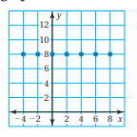 | EXAMPLE 4: Use the table to write a linear function that relates y to x.  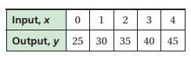
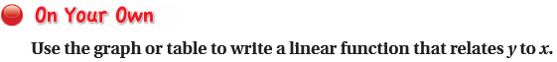
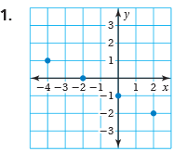 | 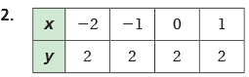
3.  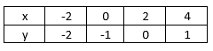 | 4.  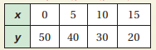
5.  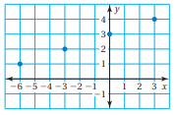 | 6.  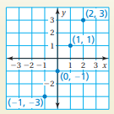
7.  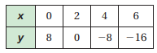 | 8.  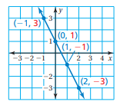

WARM UP
1. Graph y = -3  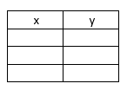  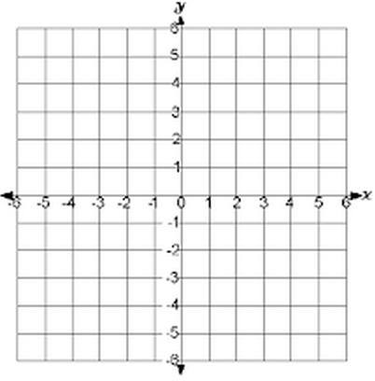 | 2. Graph x = 4 | 3. Graph $y= \frac{1}{2}x+1$  