Name: ______________________________ Table #: _______ Period: _______ Date: ______
6.3A The Percent Proportion_Classwork

Objective: use the percent proportion to find parts, wholes, and percents. CC.SS.7.RP.3
Homework: textbook- 6.3A pg 230 #11-19 ALL

Here are several aids that will help you solve word problems:
- Make sure you understand the question that is asked
- Sometimes, you will have to subtract or add some of the numbers.
- The denominator will always be the original number, price, or total.

- A baseball pitcher won 80% of the games he pitched. If he pitched 35 ballgames, how many games did he win?  percent part  out of 100 whole | - Jerry, an electrician, worked 7 months out of the year. What percent of the year did he work? Round answer to the nearest hundredth.  percent part  out of 100 whole
- There are 28 students in a class. Sixteen of those students are men. What percent of the class are women? Round to the nearest tenth.  percent part  out of 100 whole | - Donovan took a math test and got 35 correct and 10 incorrect answers. What was the percentage of correct answer? Round to the nearest hundredth.  percent part  out of 100 whole
- There are 32 students in a class. Nine of those students are women. What percent are men? Round to the nearest tenth.  percent part  out of 100 whole | - The Royals softball team played 75 games and won 55 of them. What percent of the games did he lose? Round to the nearest tenth.  percent part  out of 100 whole

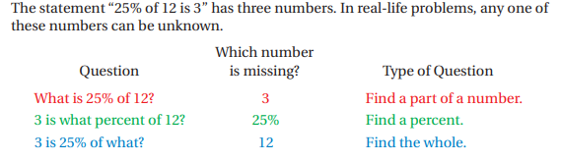
USING RATIO TABLES: Use a ratio table to answer each question.
- What number is 6% of 30?  6 percent part (“is”)  100 out of 100 30 whole(“of”) | - What number is 65% of 30?  65 percent part (“is”)  100 out of 100 30 whole (“of”)
- 18 is what percent of 40?  18 percent part (“is”)  100 out of 100 40 whole (“of”) | - 81 is 45% of what number?  45 percent part (“is”)  100 out of 100 81 whole (“of”)

YOU TRY! Write proportion and solve to find the missing value.

- What percent of 5 is 3?  - What number is 80% of 60?  - 0.1% of what number is 4? | - 25 is what percent of 20?  - 10% of 40.5 is what number?  - ½ is 25% of what number?

