Name: _____________________________ Table #: ________Period: ______Date: ______
6.3B NOTES – Linear Functions
Objective: Interpret y = mx + b as defining a linear function. Writing linear functions from tables. CCSS: 8.F.3
HW: 6.3B Homework (handout).

Example 1: You are controlling an unmanned aerial vehicle (UAV) for surveillance. The table shows the height y (in thousands of feet) of the UAV x minutes after your start its descent from cruising altitude.
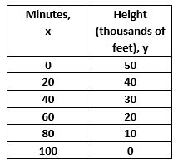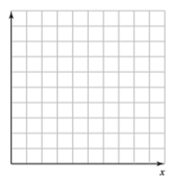

- Write a linear function that relates y to x. Then graph the linear function.

- Interpret the slope, y-intercept and x-intercept.

The slope indicates ____________________________________________________________________

The y-intercept indicates ________________________________________________________________

The x-intercept indicates ________________________________________________________________

- Find the height of the UAV after 36 minutes?

EXTRA EXAMPLE 3: The table shows the number y of calories your burn in x hours of jogging.
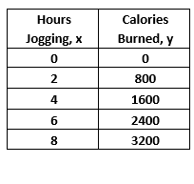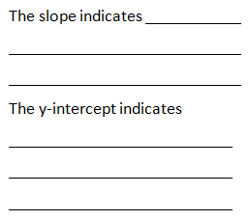

- Write a linear function that relates y to x. Then, graph the linear function. | - On the lines above, interpret the slope and y-intercept. | c. How many calories do you burn in 150 minutes?

EXTRA EXAMPLE 4: Your earnings y (in dollars) for working x hours are represented by the function
y = 6x + 12. The table shows the earnings of your friend.

Your earning: y = 6x +12 |  | Your friend’s earning:
- Write a function that relates your friend’s earning to the number of hours worked. | - Who has a higher hourly wage? |  | - Graph both functions on the same coordiante plane.

SIMILAR TEST QUESTION #18: You are looking into renting a car and are considering 2 car rental companies. Each company charges a flat rental fee and a fee per day. At XYZ Rental, the total cost y, in dollars, of renting a car x days is represented by the linear function y = 25x + 50. The table shows the total cost for renting a car x days from ABC Rental Cars.

ABC Rental Cars
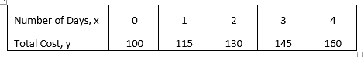

- Which company has a cheaper fee per day?

- Which company has a cheaper rental fee?

- Which company is cheaper if you want to rent a car for 8 days? HINT: use equations

SIMILAR TEST QUESTION #17: A bus travels at a constant speed. The table shows the distance y, in miles that the bus travels after x minutes. How far does the bus travel after 14 minutes? (leave your answer as an improper fraction)

