Name: _____________________________ Table #: ________Period: ______Date: ______
6.3B Linear Functions_Classwork
Objective: Interpret y = mx + b as defining a linear function. Writing linear functions from tables. CCSS: 8.F.3
HW: 6.3B Homework (handout).
Example: You are controlling an unmanned aerial vehicle (UAV) for surveillance. The table shows the height y (in thousands of feet) of the UAV x minutes after your start its descent from cruising altitude.
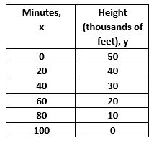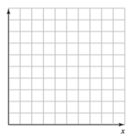

- Write a linear function that relates y to x. Then graph the linear function.

- Interpret the slope, y-intercept and x-intercept.

The slope indicates ____________________________________________________________________

The y-intercept indicates ________________________________________________________________

The x-intercept indicates ________________________________________________________________

- Find the height of the UAV after 36 minutes?

EXTRA EXAMPLE 3: The table shows the number y of calories your burn in x hours of jogging.
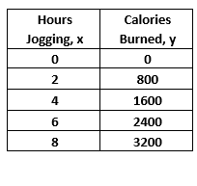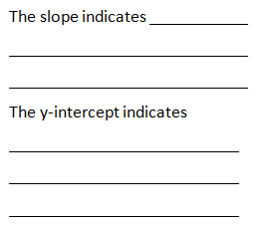

- Write a linear function that relates y to x. Then, graph the linear function. | - On the lines above, interpret the slope and y-intercept. | c. How many calories do you burn in 150 minutes?

EXTRA EXAMPLE 4: Your earnings y (in dollars) for working x hours are represented by the function
y = 6x + 12. The table shows the earnings of your friend.

Your earning: y = 6x +12 |  | Your friend’s earning:
- Graph both functions on the same coordiante plane. | - Who has a higher hourly wage? |  | - Write a function that relates your friend’s earning to the number of hours worked.

ON YOUR OWN 4: Manager A earns $15 per hour and receives a $50 bonus. The graph shows the earnings of Manager B.
- Which manager has a higher hourly wage?

- After how many hours does Manager B earn more money than Manager A?

5. MOVIES: The table shows the cost y (in dollars) of renting x movies.
- The independent variable is ___________________________

The dependent variable is ____________________________

- Write a linear function that relates y to x. Interpert the slope.

Linear function: _____________________________________

The slope in the linear function means: __________________

- Graph the linear function

- How much does it cost to rent 3 movies?
It costs _________ to rent 3 movies.

