Name: _________________________ Table #: _______ Period: ______ Date: ________
6.4 NOTES – Comparing Linear and Nonlinear Functions
Objective: Determine whether tables, graphs and equations are linear or nonlinear.
HW: (6.4) p. 270 #1, 3 – 10, 12 - 16 (Solutions on p. A30)

LESSON LAUNCH: Look at the rate of change for each table. Determine if the rate of change is constant or not constant and use that information to determine whether the function is linear or non-linear. Note whether or not the function can be written in slope-intercept form.
1. y = x + 2 2. y = 2x
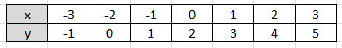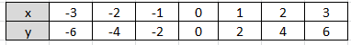

___________________________________ ___________________________________
3. y = x² 4. $y= \frac{2}{x}$
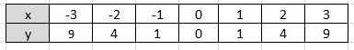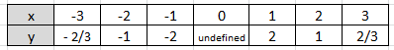

___________________________________ ___________________________________
Read the Examples 1 – 4 on p. 268-269. Do ON YOUR OWN Problems #1- 6
DOES THE TABLE OR GRAPH REPRESENT A LINEAR OR NONLINEAR FUNCTION? EXPLAIN
Example 1:  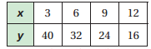 | Example 2:  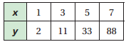 | Example 3:  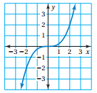 | Example 4:  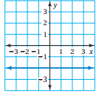

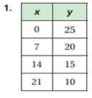 | 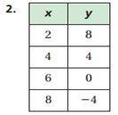 | 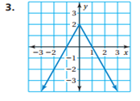

EXAMPLE 3 (p.269): Which equation(s) represents a nonlinear function?
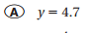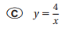

DOES THE EQUATION REPRESENT A LINEAR OR NONLINEAR FUNCTION? EXPLAIN
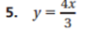

7. VOLUME. The table shows the volume V (in cubic feet) of a cube with an edge length of x feet. Does the table represent a linear or nonlinear function? EXPLAIN.

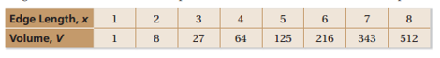

8. SIMILAR TEST QUESTION #13: The table represents a LINEAR FUNCTION that shows the amount of money saved after x weeks. Complete the table.
Week, x | Savings ($), y
0 | 20
1 | ?
2 | 58

9. SIMILAR TEST QUESTION #13:  The graph of a function is a line that passes through the points (1, 1), (3, 7) and (4, y). What is the value of y? | 10. SIMILAR TEST QUESTION #13:  The graph of a function is a line that passes through the points (2, 0), (5, 18) and (10, y). What is the value of y?
Summary: IS IT LINEAR OR NONLINEAR?
Type of Function | LINEAR | NONLINEAR
Graph
Equation
Table

