Name: ________________________ Table #: _______Period: __________ Date: _____

**6.4A The Percent Equation_Classwork**

*Objective: use the percent equation to find parts, wholes, and percents. CC.SS.7.RP.3/EE.3*

*HW: textbook- 6.4A pg 236_#10-19 ALL*

|  |
| --- |
| **WARM-UP**  1.  2.  3.  4.  5.  6. |

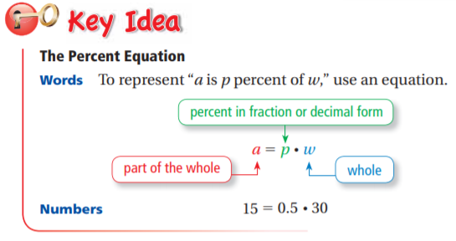

|  |  |  |
| --- | --- | --- |
| **FINDING A PART OF A NUMBER** | **FINDING A PERCENT** | **FINDING A WHOLE** |
| **Example 1**  What number is 24% of 50? | **Example 2**  9.5 is what percent of 25? | **Example 3**  39 is 52% of what number? |

**ON YOUR OWN**

|  |  |  |
| --- | --- | --- |
| 1. What number is 10% of 20? | 1. What number is 150% of 40? | 1. 3 is what percent of 60 |
| 1. 18 is what percent of 20? | 1. 8 is 80% of what number? | 1. 90 is 18% of what number? |