Name: ________________________ Table #: _______Period: __________ Date: _____
6.4B The Percent Equation_Classwork
Objective: use the percent equation to find parts, wholes, and percents. CC.SS.7.RP.3/EE.3
HW: 6.4B worksheet

REAL-LIFE APPLICATION: School Election
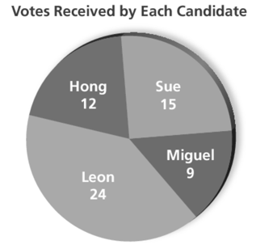  The circle graph shows the number of votes received by each candidate during a school election. So far, only half the students have voted. | - Complete the table.  - Find the percent of students who voted for each candidate.  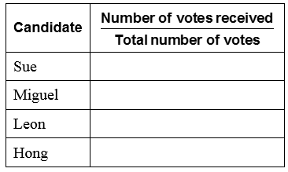

REAL-LIFE APPLICATION: School Election 2
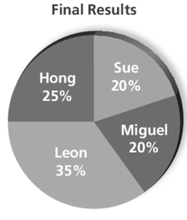  The graph shows the final results of the election in percent.  Use School Election 1 to find the total votes. | - Find the number of students who voted for each candidate.

REAL-LIFE APPLICATION: 8th Street Café Spending
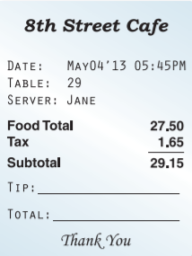  Mary and Sam went out and eat. Above is the bill for their meals. | - Find the percent of sales tax on the food total.  - Find the amount of a 16% tip on the food total.  - Find the amount of a 20% tip on the subtotal.

Practice Problems
- You receive 15% of the profit from a car wash. How much money do you receive from a profit of $300?

- A salesperson receives a 2.5% commission (extra money on top of what they have already earned). What commission does the salesperson receive for $8000 in sales?

- Your school raised 125% of its fundraising goal. The school raised $6750. What was the goal?

- A surfboard costs $240. The sale tax on the surfboard is $12. What is the percent of sales tax (extra money you have to pay)?

