Name: _____________________________________ Table #: ________Period: ______Date: ______
6.5A Analyzing and Sketching Graphs_Classwork
Objective: analyze the relationship between two quantities using graphs; sketch graphs to represent the relationship between two quantities. CC.SS.8.F.5
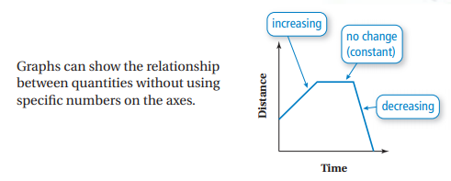
EXAMPLE 1:  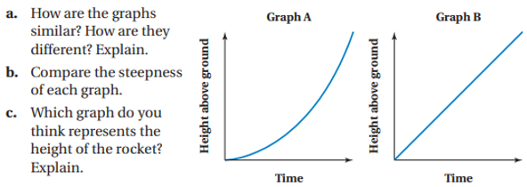  a.  b.  c. | EXAMPLE 2:  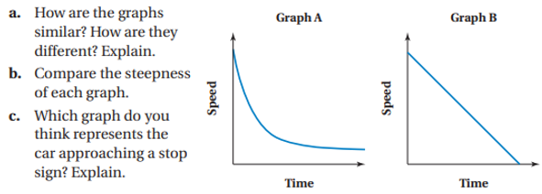  a.  b.  c.
EXAMPLE 3:
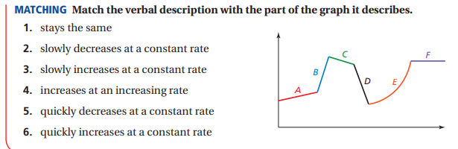

BACK
EXAMPLE 4: Matching Situations to Graphs – You are riding your bike. Match each situation with the appropriate graph. Explain your reasoning.

4. ____
3. ____
2. ____
1. ____

YOU TRY! Match the correct graph to the correct scenario. Write the answer in the circle.
1.
2.
3.
4.

