Name: ______________________ Table #: ______________ Period: ______ Date: _______
6.5A Percent Increase and Decrease_Classwork
Objective: find percents of increase; find percent of decrease. CC.SS.7.RP.3
HW: 6.5A pg 244_#8-17 ALL

WARM-UP
- Solve for x:  $$2\left(x-3\right)=6$$ | - What is 40% of 150? | - Convert 3.14 as fraction and percent.

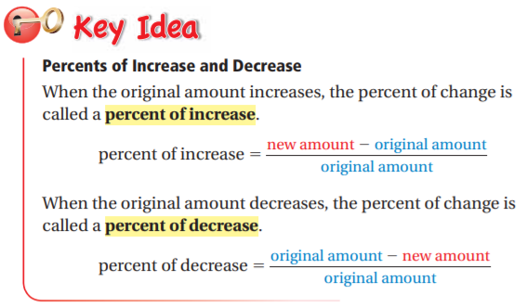

EXAMPLE 1: Finding a Percent of Increase  The table shows the numbers of hours you spend online last weekend. What is the percent of change in your online time from Saturday to Sunday?  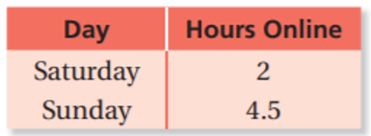 | EXAMPLE 2: Finding a Percent of Decrease  The bar graph shows a softball player’s home run totals. What was the percent of change from 2012 to 2013? Round to the nearest hundredth.  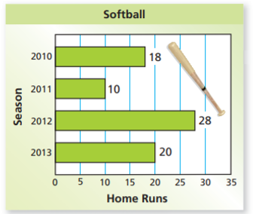

Decide whether the change is an increase or decrease and find the percent using the formula: $\frac{change}{orginal}$
- Before: 10; After: 12 | - Before: 15; After: 12 | - Before: 75; After: 60

Round to the nearest hundredth if possible.

- Before: 110; After: 143 | - Before: 90; After: 200 | - Before 260; After: 160
- 1994 cost: $171.33;  1995 cost: $201.59 | - Regular Price: $31.99;  Sale Price: $22.39 | - Start Price: $521.73;  End Price: $413.68
- 2004 cost: $18.77;  2005 cost: $19.17 | - Original Number: 45;  New Number: 72 | - Original Number: 45;  New Number: 18

