Name: ______________________ Period: __________ Date: _______
6.5B Percent Error_Classwork
Objective: find percents of increase; find percents of decrease, find percent error. CC.SS.6.RP.3
HW: 6.5B worksheet

WARM-UP
- What number is 25% of 64? | 2. 39.2 is what percent of 112? | 3. 5 is 20% of what number?

REVIEW OF PERCENT INCREASE AND DECREASE
EXAMPLE 1:
The table shows population data for a community.
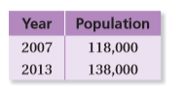 | - What is the percent of change from 2007 to 2013? Round to the nearest whole number. | - Use this percent of change to predict the population in 2019.

EXAMPLE 2:
Suppose the length and the width of the sandbox are doubled.
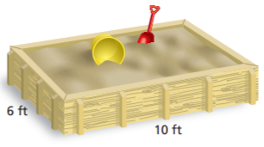 | - Find the percent of change in the perimeter. | - Find the percent of change in the area.

EXAMPLE 3:
Find the new amount.
- 8 meters increased by 25% | - 10 liters increased by 60% |  | - 50 points decreased by 26%
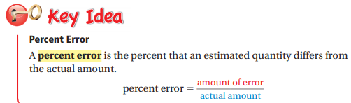 |  | 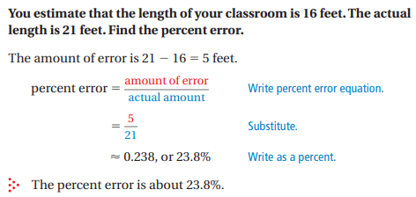

EXAMPLE 1:
You estimate that 200 people attended a school concert. The actual attendance was 240 people. Find the percent error. Round to the nearest tenth.

PRACTICE PROBLEMS
- Dennis wants to buy a card for his wife. Dennis calculates the amount of the card as $5.50. The actual price of card is $4. What is Dennis’s percent error? | - Elena’s math class had 26 students yesterday. She miscounted the class total and recorded it as 20 students. What is Elena’s percent error? Round to the nearest hundredth.
- Sabrina calculates the cost of a book as $47. The actual price was $56. What is Sabrina’s percent error? Round to the nearest hundredth. | - Maria thinks the cost to rent scooters was $95. The actual price is $150. What is Maria’s percent error? Round to the nearest hundredth.
- Jillian calculates that it will take 105 minutes to run 7 miles. She runs the distance in 80 minutes. What is Jillian’s percent error? | - Hunter thought he purchased an umbrella for $72. The actual price of an umbrella is $50. What is Hunter’s percent error?

