Name:___________________________ Partner Name: _______________________ Date __________ Period _________

Discount Advertisement Activity_Classwork

Name and Cost of Items | Picture of Items and Percent of Discount | Show Work | Discounted Price | Selling Price

Cost of Item #1 __________________

Cost of Item #2 __________________

Tax is 8.50% __________________

Total Payment: __________________

MACY’S: 30% OFF

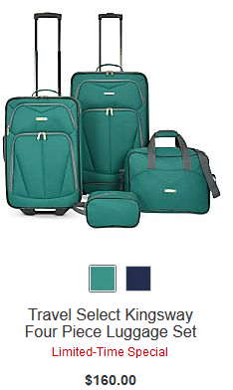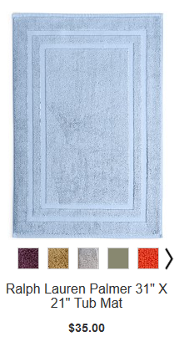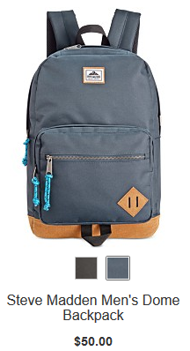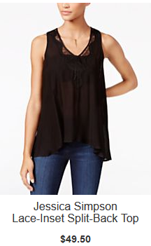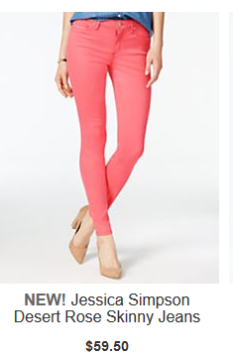

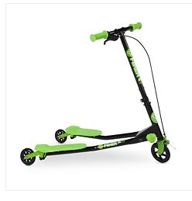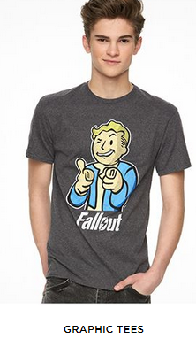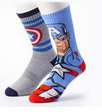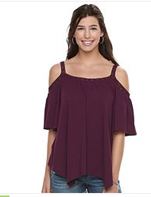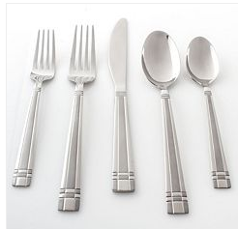
$100 $45 $16 $30 $69

