Name: _____________________________ Table #: ____________ Period: ______ Date: ______

**6.7A Simple Interest_Classwork**

*Objective: use the simple interest formula to find interest earned or paid, annual interest rates, and amounts paid on loans. CC.SS.7.RP.3*

*HW: textbook- pg 256_ #9-19 ALL*

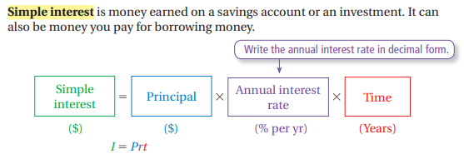

**I=PRT**

An account earns simple interest. (a) Find the interest earned. (b) Find the balance of the account.

1. $400 at 7% for 3 years 2. $1200 at 5.6% for 4 years

Find the annual interest rate.

3.  4. 

Find the amount of time.

5.  6. 

7. You put $500 in a savings account. The account earns $15.75 simple interest   
in 6 months. What is the annual interest rate?

Warm Up

For use before Lesson 6.6

Lesson

6.6

Find the cost to store, percent of markup, or selling price.

1. Cost to store: $20 2. Cost to store: $65  
Markup: 15% Markup: 30%  
Selling price:  Selling price: 