Name: _____________________________ Table #: ____________ Period: ______ Date: ______
6.7B Simple Interest_Classwork
Objective: use the simple interest formula to find interest earned or paid, annual interest rates, and amounts paid on loans. CC.SS.7.RP.3 HW: 6.7B worksheet
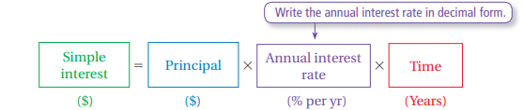
EXAMPLE 1: Finding Interest Earned  You put $500 in a savings account. The account earns 3% simple interest per year.  - What is the interest earned after 3 years? _______  - What is the balance after three years? __________ | EXAMPLE 2: Finding an Annual Interest Rate  You put $1000 in an account. The account earns $100 simple interest in 4 years. What is the annual interest rate?
EXAMPLE 3: Finding an Amount of Time  A bank offers three saving accounts. The simple interest rate is determined by the principal. How long does it take an account with a principal of $800 to earn $100 interest? | EXAMPLE 4: Finding an Amount Paid on a Loan  You borrow $600 to buy a violin. The simple interest rate is 15%. You pay off the loan after 5 years. How much do you pay for the loan?
PRACTICE PROBLEMS

- Jay borrowed $15,000 for one year from a bank in order to buy a motocyle. He agreed to pay an interest rate of 8% per yar. At the end of one year, how much money would Jay pay back to the bank?

- You want to borrow $10,000 from a bank. The following are interest rates at different finanical institutions. How much would you owe in interest after one year at each bank? Which is the best rate?
- Navy Fed Bank 3.45% | - Chase Bank 3.5% | - Bank of America 3.48%

++++++++++++++++++++++++++++++++++++++++++++++++++++++++++++++++++++++++++++++++++++++
Warm-Up

Find the sale price for the item. Round to the nearest cent.
- Original price: $300; Discount: 25%

2. Original price: $75; Discount: 40%

