Name: _____________________________ Table #: ____________ Period: ______ Date: ______
6.7B HW
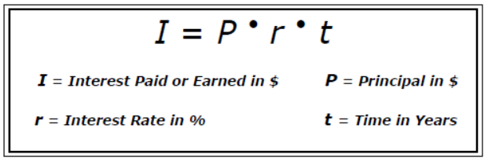

BACK

