Name:____________________________________________________ Table# _______ Per.____ Date _________ Ch. 6 Study Sheet
Create examples for each category listed from Chapter 6
DIFFERENT FORMS OF RELATIONS. Create 5 ordered pairs, then fill in the other forms from those ordered pairs. (HINT: make sure it is y=mx+b)
Table | Ordered Pairs | Mapping Diagram | Graph  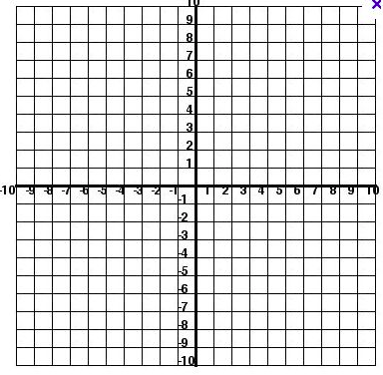 | Equation | Written Sentence
Create examples of relations that are FUNCTIONS. Explain why each is a function.
Ordered Pairs | Mapping Diagrams | Tables | Graphs
Create examples of relations that are NOT FUNCTIONS. Explain why each is not a function.
Ordered Pairs | Mapping Diagram | Tables | Graphs
Create example slopes and sketch the graphs
POSITIVE SLOPE  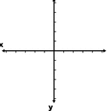 | NEGATIVE SLOPE | ZERO SLOPE | UNDEFINED SLOPE
Create tables and graphs and then write their function rules.
CREATE A TABLE. THEN FIND THE LINEAR FUNCTION IN y = mx + b  x y | CREATE A TABLE. THEN FIND THE LINEAR FUNCTION IN y = mx + b  x y
CREATE A LINEAR GRAPH. THEN WRITE THE LINEAR FUNCTION IN y = mx + b, THAT RELATES Y TO X. | CREATE A LINEAR GRAPH. THEN WRITE THE LINEAR FUNCTION IN y = mx + b, THAT RELATES Y TO X.
Create equations and then make tables to graph
Equation in y = mx + b (slope (m) is an integer) | Equation in y = mx + b (slope (m) is a fraction) | Graph of the equation produces a horizontal line | Graph of the equation produces a vertical line

