Name Date

7.1 and 7.2 Review NOTES

**Use 7.1 notes**

Find the dimensions of the square or circle. Check your answer.

1.  2. 

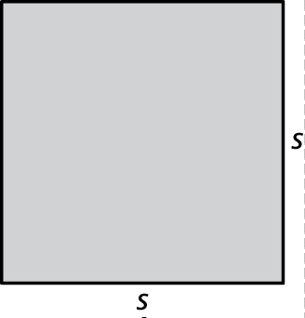 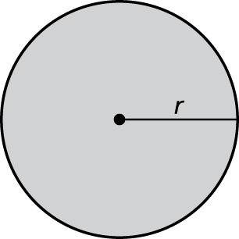

S = _______________ r = __________

Find the two square roots of the number.

3. 16 4. 100

______ and _____ ______ and _____

Find the square root(s).

5. = _________ 6.  =_______

7.  =_______ 8.  =_______

Evaluate the expression.

9.  = _______ 10.  =_________

Copy and complete the statement with 

11.  12. 

**BACK 🡪**

Name Date

Use 7.2 notes

Find the edge length of the cube.

1.  2. 

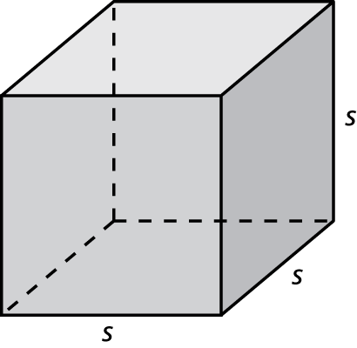 

s = ____________ s = ____________

Find the cube root.

3.  4.  5.  6. 

______ ______ _____ ____

7.  8.  9.  10. 

_____ _____ _____ _____

Copy and complete the statement with 

11.    12.   