Name: _____________________ Table #: _______ Period: _____ Date: _____
7.1A Adjacent and Vertical Angles_Classwork
Objective: identify adjacent and vertical angles; find angle measures using adjacent and vertical angles. CC.SS.7.G.5
HW: 7.1A worksheet
ADJACENT ANGLES
Two angles are adjacent angles when they ______________ a common side and have the _____________ vertex.
EXAMPLE 1 | Two examples for adjacent angles:  Two examples for non-adjacent angles:
++++++++++++++++++++++++++++++++++++++++++++++++++++++++++++++++++++++++++++++++++++++++++++
VERTICAL ANGLES
Two angles are vertical angles when they are ________________ angles formed by the ___________________ of two lines. Vertical angles are _________________ angles, meaning they have the _________________ measure.
EXAMPLE 2 | Two examples for vertical angles:  Two examples for non-vertical angles:
++++++++++++++++++++++++++++++++++++++++++++++++++++++++++++++++++++++++++++++++++++++++++++
LINE:
A straight line that as a measurement of _________. Two angles that form a straight line is called _____________________________.
EXAMPLE 3 | Two examples for linear pairs  Two examples for non-linear pairs:

EXAMPLE 4  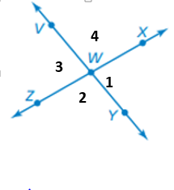 | There are different ways to write angle notation: $∡1 or ∡XWY$  $$∡1$$ $$∡XWY$$ or $$∡YWX$$ $∡1$ is adjacent to _____________________ $∡1$ and _____________ are vertical angles  $$∡2$$  $$∡3$$  $$∡4$$

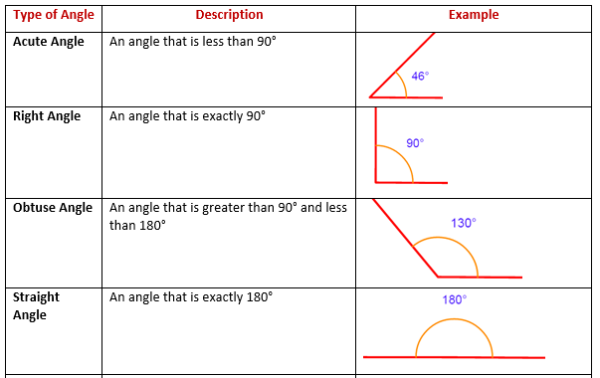

EXAMPLE 5 Name two pairs of adjacent angles and two pairs of vertical angles in the figure.
1.  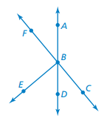 | Adjacent Angles:  *  *  Vertical Angles  *  * | 2. | Adjacent Angles:  *  *  Vertical Angles  *  *

EXAMPLE 6 Draw a pair of adjacent angles with the given description.
- Both angles are acute | - One angle is acute, and one is obtuse. | - The sum of the angle measures is 135°.

EXAMPLE 7 Use the diagram below to determine whether the statement is ALWAYS, SOMETIMES, or NEVER TRUE. Explain why.
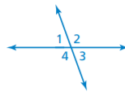 | - When the measure of ∠1 is 70°, the measure of ∠3 is 110°.  - When the measure of ∠4 is 120°, the measure of ∠1 is 60°.  - ∠2 and ∠3 are congruent.  - The measure of ∠1 plus the measure of ∠2 equals the measure of ∠3 plus the measure of ∠4.

