Name Date

7.1A Homework

Name two pairs of adjacent angles and two pairs of vertical angles in   
each problem figure.

1. 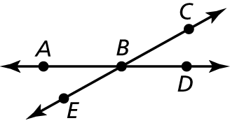 2. 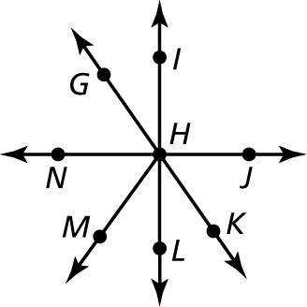

Adjacent Angles:

Vertical Angles:

Adjacent Angles:

Vertical Angles:

3. 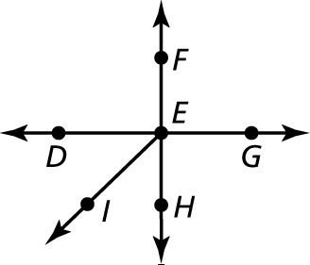 4. 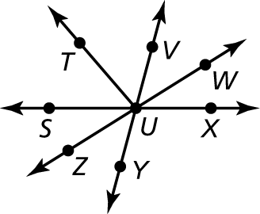

Adjacent Angles:

Vertical Angles:

Adjacent Angles:

Vertical Angles:

Tell whether the angles are *adjacent* or *vertical*. EXPLAIN.

5. 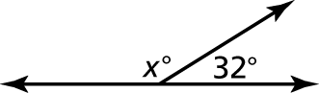 6. 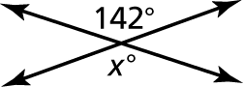

7. 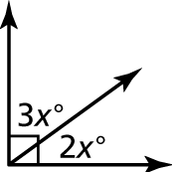 8. 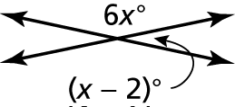

9. 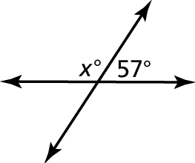 10. 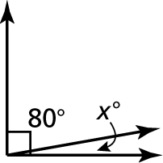

11. 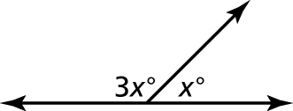 12. 