Name: __________________ Table #: _____ Period: ______ Date: _____
7.1A Finding Square Roots_Classwork
Objective: Apply areas and side lengths of squares to finding the square root of perfect squares. (CC.SS.8.EE.2;MP6 Attend to Precision)
HW: (7.1A) p. 292 #1, 4, 5, 7 – 19 (Solutions on p. A31)

Find the area, A, of the squares given the side length, s. (A = s²)
1. s = 10  A = ____ | 2. s = 12  A = ____ | 3. s = 20  A = ____ | 4. s = 14  A = ____
5. s = 0.5  A = ____ | 6. s = $\frac{2}{3}$  A = ____ | 7. s = 1.5  A = ____ | 8. s = $1\frac{1}{3}$  A = ____

$→$ESSENTIAL QUESTION: How can you find the area of a square when given the square’s dimensions?____________________________________________________________________

Find the side of the square, s, when given the area of the square, A.
9.  A = 25  s = ____ | 10.  A = 16  s = ____ | 11  A = 121  s = ____ | 12.  A = 225  s = ____
13.  A = $\frac{1}{4}$  s = ____ | 14.  A = 1  s = ____ | 15.  A = 0.64  s = ____ | 16.  A = $\frac{4}{25}$  s = ____

$→$ESSENTIAL QUESTION: How can you find the dimensions of a square when you are given its area?______________________________________________________________________
7.1A (p. 288) – FINDING SQUARE ROOTS
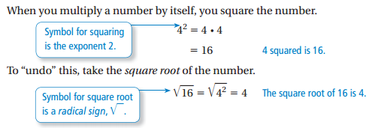

READ P. 290 EXAMPLES 1 AND 2. FILL IN THE BLANKS AND DO “ON YOUR OWN” #1 – 6

VOCABULARY:
A _______________ __________________ is a number with integers as its square roots.

A ______________ __________________ is this symbol, (It is used to represent a square root.

A ________________________ is the number under the radical sign.

An ______________ is the small number that is sitting on top of the radical sign. $\sqrt[2]{}$
$$The square root is the only one that can be written in two ways: \sqrt{} or \sqrt[2]{}$$

FROM EXAMPLE 1:
Positive Square Root, | Negative Square Root, $-\sqrt{}$ | Both Square Roots, $±\sqrt{}$
$$\sqrt{16}= _______$$ | $$-\sqrt{16}= _______$$ | $$±\sqrt{16}= __________$$

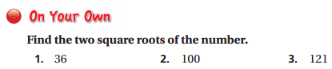

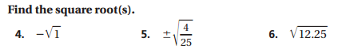

Video to watch: https://www.khanacademy.org/math/algebra/rational-exponents-and-radicals/alg1-radicals/v/introduction-to-square-roots

