Name: _____________________ Table #: _______ Period: _____ Date: _____
7.1B Adjacent and Vertical Angles_Classwork

Objective: identify adjacent and vertical angles; find angle measures using adjacent and vertical angles. CC.SS.7.G.5
Homework textbook: 7.1B pg 274_1-13 ALL

WARM-UP ACTIVITY
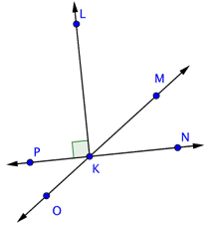
List as many angles that you see | List as many adjacent angles that you see | List as many vertical angles that you see

EXAMPLE Tell whether the angles are adjacent or vertical angle. Then find the value of x.
1.  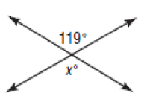  _______________________  X = ___________________ | 2.  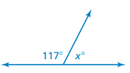  _______________________  X = ___________________ | 3.  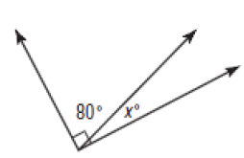  _______________________  X = ___________________
4.  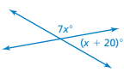  _______________________  X = ___________________ | 5.  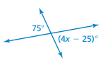  _______________________  X = ___________________ | 6.  _______________________  X = ___________________
PRACTICE PROBLEMS
Name two pairs of adjacent angles and two pairs of vertical angles in the figure.
1.  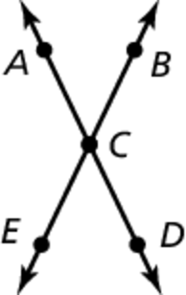 | Adjacent Angles:  *  *  Vertical Angles  *  * | 2.  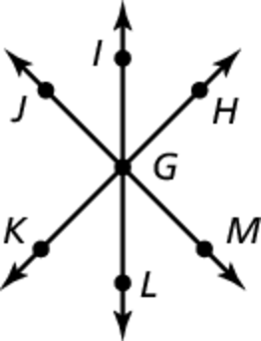 | Adjacent Angles:  *  *  Vertical Angles  *  *

Tell whether the angles are adjacent or vertical. Then find the value of x.
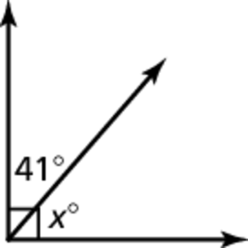  3.  _______________________  X = ___________________ | 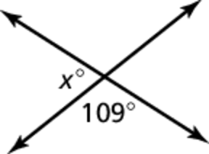  4.  _______________________  X = ___________________
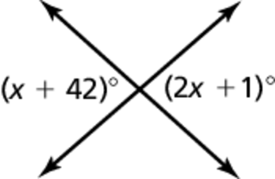  5.  _______________________  X = ___________________ | 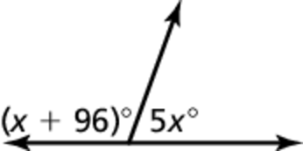  6.  _______________________  X = ___________________

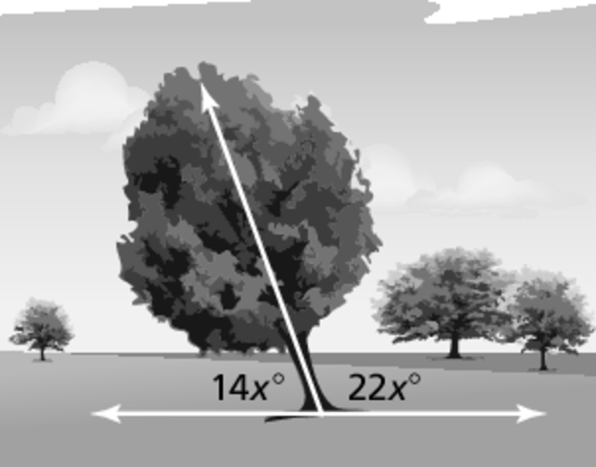
7. A tree is leaning toward the ground. How many degrees
does the tree have to fall before hitting the ground?

