Name: __________________ Table #: _____ Period: ______ Date: _____
7.1B Finding Square Roots_Classwork
LESSON OPENER
1 . 3 + 8 = 11  11 – 3 = 8  Provide 2 more examples of subtraction undoing addition. | a. | b.
2. 5 $∙$ 3 = 15  15 $÷$ 5 = 3  Provide 2 more examples of division undoing multiplication. | a. | b.
3. 4² = 16  $\sqrt{16}=4$  Provide 2 more examples of square root undoing a square. | a. | b.

4. Explain how a square root undoes a square. If you want to use an example, you may use one of
your examples above with your explanation.

Squaring a positive number and finding a square root are inverse operations. You can use this relationship to evaluate expressions and solve equations involving squares.

Copy the examples from the textbook and Video Tutors in B.I.M.
7.1, Example 3 (p. 291)  Evaluate each expression  - $5\sqrt{36}+7$  - $\frac{1}{4}+ \sqrt{\frac{18}{2}}$  - ${\left(\sqrt{81}\right)}^{2}-5$ | Video Tutor 7.1, Example 3  Evaluate each expression  - $2\sqrt{144}-30$  - $\sqrt{\frac{36}{4}}+ \frac{1}{6}$  - $49- {\left(\sqrt{49}\right)}^{2}$
On Your Own problems #7 – 10 (p. 291). DIRECTIONS: Evaluate the expression.
7. $12-3\sqrt{25}$ | 8. $\sqrt{\frac{28}{7} +2.4}$ | 9. $15- {\left(\sqrt{4}\right)}^{2}$

7.1, Example 4 (p. 291)
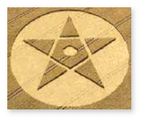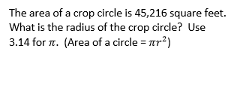
Video Tutor 7.1, Example 4
What is the radius of the circle? Use 3.14 for $π.$
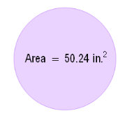

On Your Own
10a. The area of a circle is 2826 square feet. Write and solve an equation to find the
radius of the circle. Use 3.14 for $π.$

10b. The area of a circle is $225π {in.}^{2}$. Write and solve an equation to find the radius
of the circle.

HW: 7.1B Homework (handout)
Objective: Evaluate expressions using square roots. (8.EE.2)

