Name: __________________ Table #: _____ Period: ______ Date: _____
7.1C Finding Square Roots_Classwork
Objective: Evaluate expressions using square roots. (8.EE.2)

Definition of a “simplified form” for a square root the square root of a positive integer is in “simplest form” if the “radicand” has no perfect square factor other than one.

Perfect Square table
1x1= | 2x2= | 3x3= | 4x4= | 5x5= | 6x6= | 7x7=
8x8= | 9x9= | 10x10= | 11x11= | 12x12= | 13x13= | 14x14=
15x15= | 16x16= | 17x17= | 18x18= | 19x19= | 20x20= | 21x21=

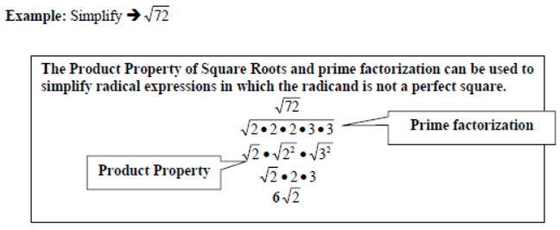
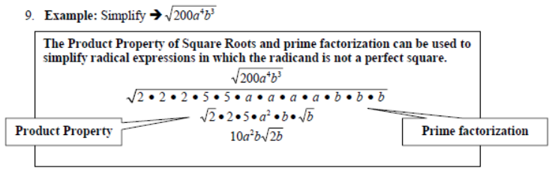

1.  $$\sqrt{8}$$ | 2.  $$\sqrt{96}$$ | 3.  $$\sqrt{175}$$
4.  $$\sqrt{80m^{3}}$$ | 5.  $$\sqrt{147{xm}^{3}}$$ | 6.  $$\sqrt{45n^{2}m^{3}}$$

Login BIM and do 7.1C CW. Copy down the problem, show work (if necessary), and circle the answer.
1. | 2. | 3.
4. | 5. | 6.
7. | 8. | 9.

