Name: ____________________ Table #:___________ Period: _______ Date: _____

**7.2A Complementary and Supplementary Angles _Classwork**

*Objective: classify pairs of angles as complementary, supplementary, or neither; find angle measures using complementary and supplementary angles. CC.SS.7.G.5*

*HW: 7.2A worksheet*

|  |
| --- |
| **COMPLEMENTARY ANGLES**  Two angles are complementary angles when the angles add up to __________. Complementary angles form a _________________________ __________________________.    **SUPPLEMENTARY ANGLES (linear pair)**  Two angles are supplementary angles when the angles add up to ___________. Supplementary angles form a ______________________________ _______________________. |

|  |  |
| --- | --- |
|  | 1. Name four pairs of complementary angles. 2. Name four pairs of supplementary angles. 3. Name two pairs of vertical angles. |

BACK 🡪

**For #1-6, use the figure at the right.**

1. Name two acute vertical angles.
2. Name two obtuse vertical angles.
3. Name a linear pair.
4. Name two acute adjacent angles.
5. Name an angle complementary to .

1. Name an angle supplementary to .

**Find the measure of each numbered angle.**

**7. 8. 9.**

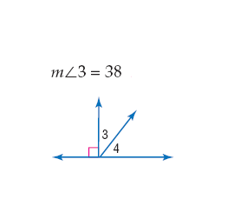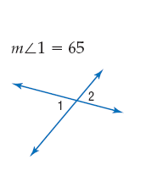

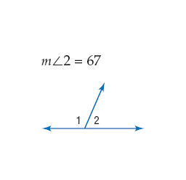**10. 11. 12.**

