**Identify each pair of angles as adjacent, vertical, complementary, supplementary, or a**

**linear pair.**

**1.** 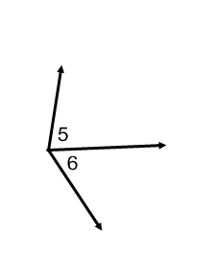

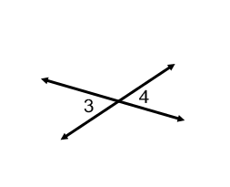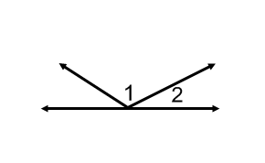 **2. 3.**

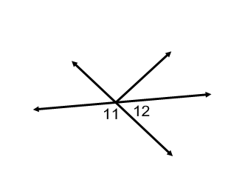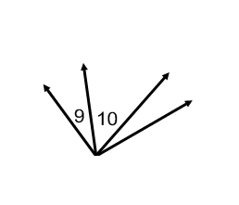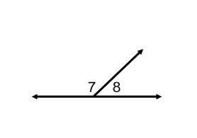

**4. 5. 6.**

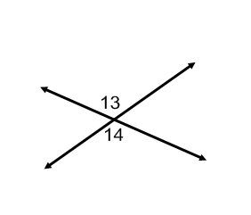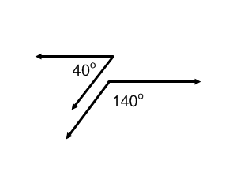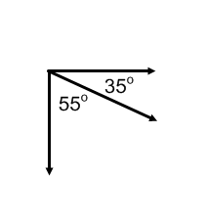

**7. 8. 9.**

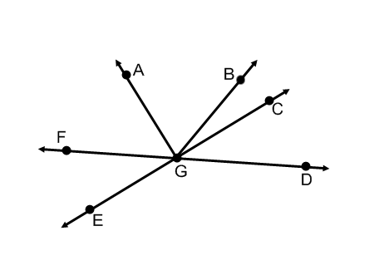**Use the figure at the right to answer each question.**

1. Name two acute vertical angles.
2. Name two obtuse vertical angles.
3. Name a pair of adjacent angles
4. Name a linear pair.
5. Name a pair of complementary angles.
6. Name an angle supplementary to 