Name: ___________________________________________ Table #: ______ Period: _____ Date: _____
7.2A Finding Cube Roots_Classwork
Objective: Evaluate cube roots of perfect cubes. Use cube roots to solve equations. (CCSS: 8.EE.2)
VIDEO: https://www.youtube.com/watch?v=Kpnad_I138Y

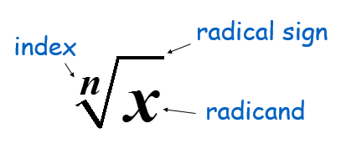 | 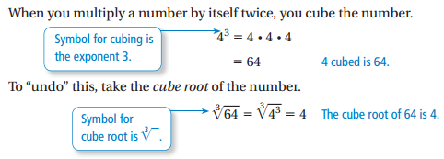
Fill in the chart:
$$1^{3}=$$ | $$2^{3}=$$ | $$3^{3}=$$ | $$4^{3}=$$ | $$5^{3}=$$ | $$6^{3}=$$
$$7^{3}=$$ | $$8^{3}=$$ | $$9^{3}=$$ | $${10}^{3}=$$ | $${11}^{3}=$$ | $${12}^{3}=$$
$${(-1)}^{3}=$$ | $${(-2)}^{3}=$$ | $${(-3)}^{3}=$$ | $${(-4)}^{3}=$$ | $${(-5)}^{3}=$$ | $${(-6)}^{3}=$$
$${(-7)}^{3}=$$ | $${(-8)}^{3}=$$ | $${(-9)}^{3}=$$ | $${(-10)}^{3}=$$ | $${(-11)}^{3}=$$ | $${(-12)}^{3}=$$
Copy examples 1-3, p. 296-7. Then do On Your Own #1 – 8
EXAMPLE 1: Finding Cube Roots
a. $\sqrt[3]{8}$ | b. $\sqrt[3]{-27}$ | c. $\sqrt[3]{\frac{1}{64}}$
ON YOUR OWN
- $\sqrt[3]{1}$ | - $\sqrt[3]{-343}$ | - $\sqrt[3]{-\frac{27}{1,000}}$
EXAMPLE 2: Evaluating Expressions Involving Cube Roots
$$a. 2\sqrt[3]{-216}-3=$$ | b. ${\left(\sqrt[3]{125}\right)}^{3}+21$
ON YOUR OWN. Evaluate the expression.
- $18-4\sqrt[3]{8}=$ | - ${\left(\sqrt[3]{-64}\right)}^{3}+43$ | - $5\sqrt[3]{512}-19$

EXAMPLE 3: Evaluating an Algebraic Expression
- $\frac{x}{4}+\sqrt[3]{\frac{x}{3} } when x=192$ | - $\frac{w}{30}+\sqrt[3]{\frac{w}{5} }$  $$when w=1080$$ | - $\sqrt[3]{3375}$
ON YOUR OWN. Directions: Evaluate the expression for the given value of the variable.
- $\sqrt[3]{8y}+y when y=64$ | - $2b- \sqrt[3]{9b}$ when b = -3

HW: (7.2A) p. 298 #1, 9-11 ALL, 12, 14, 18-20 ALL (Solutions on p. A32)
Copy down the problem. Show your work. Check your answers
EVEN SOLUTIONS: 4) $\frac{1}{3}ft.$ 6) 9 8) -10 10) $-\frac{1}{8}$ 12) -9

