Name: _________________________________ Table #: ________ Period: _____Date: _______
7.3A Right Triangle Investigation_Classwork
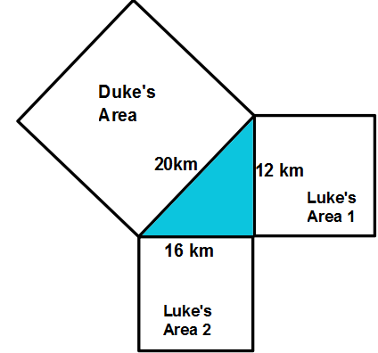
Objective: Apply the Pythagorean Theorem to real-life application(CCSS: 8.G.8)
- Mr. Wrangler gave each of his sons Luke and Duke square shaped property around a triangular lake. Luke wanted more shoreline so he gave Luke two smaller pieces on the shorter sides of the lake. Duke wanted less shoreline and lots of wide open space so his father gave him the big square piece on the long side of the lake. Luke was sure that he had more land since he had two pieces. Duke was sure he had more land since his piece was larger than either of Luke's pieces. Let's settle the argument. Was it split fairly? Explain
CLAIM (What is the answer?)

EVIDENCE (What work did you do to derive your answer?)

REASONABLE (Write a couple sentences to explain your evidence)

______________________________________________________________________________________
- Luke has two pieces of land on the shorter sides of the lake. Duke has one piece of land on the longest side of the lake.
- Find the Area of each square formed by the sides of the triangle (around Lake 2)

- Was the land split fairly?

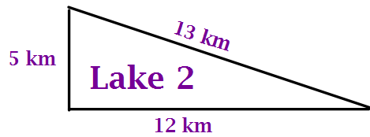

BACK
- Sketch a right triangle with legs (the shorter sides) of 8 and 15 and the hypotenuse (the side opposite the right angle) 17. Using what you learned about Lake 1 and Lake 2, see if the same principal holds true for other right triangles. Show all of your work.

PRACTICE PROBLEMS
Using what you have learned about right triangles, find the missing sides.
1.  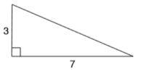  ANSWER: | 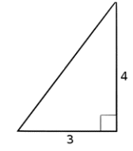  2.  ANSWER: | 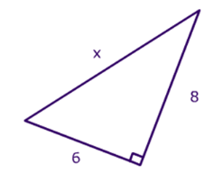  3.  ANSWER:
4.  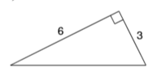  ANSWER: | 5.  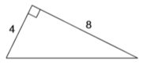  ANSWER: | 6.  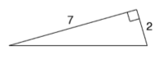  ANSWER:
7.  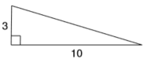  ANSWER: | 8.  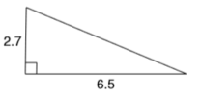  ANSWER: | 9.  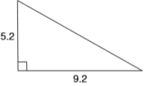  ANSWER:
You tube videos:
https://www.youtube.com/watch?v=CAkMUdeB06o (Pythagorean Theorem – Water Demo)
https://www.youtube.com/watch?v=uaj0XcLtN5c (Pythagorean Theorem in 2 minute

