Name: ________________________ Table #: ______ Period: _______ Date: _______
7.3A Triangles_Classwork
Objective: construct triangles with given angle measures; construct triangles with given side lengths. CC.SS.7.G.2
HW: 7.3A worksheet
ACTIVITY 1: Constructing Triangles Using Sides Lengths
Construct a triangle with the specified straws if possible. Compare your results with your table.
Red
Blue
Green
Purple
 | Blue/green/purple straws | Red/Green/Purple straws | Red/Blue/Purple straws | Red/Blue/Green straws
Side Length of the longest one

Sum of other two sides lengths

RULE: Write a rule that compares the sum of any two side lengths to the third side length.

Practice Problems:
- Can a triangle have side lengths 22, 33, 25? Why or why not? Show your work.

- Can a triangle have side lengths 3, 7, 11? Why or why not? Show your work.

- Two sides of a triangle are 15 ft and 12 ft. What could be the longest length?

RULE: Sum of the Angle Measures of a Triangle
“The sum of the angle measures of a triangle is 180°.”
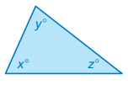

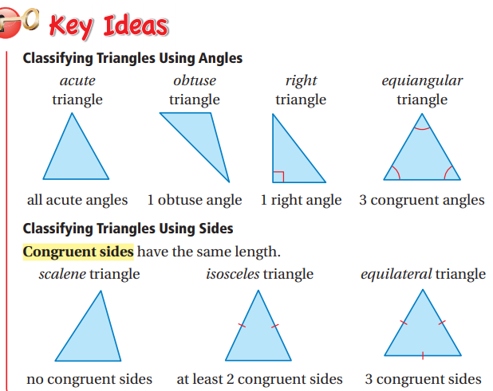

PRACTICE PROBLEMS
