Name: _________________________________ Table #: ________ Period: _____Date: _______

**7.3B NOTES - The Pythagorean Theorem (FINDING A LEG)**

*Objective: Apply the Pythagorean Theorem to determine unknown distances on triangles (CCSS: 8.G.8)*

*HW: (7.3B) p. 304 #3 – 12 all. Do in Big Ideas Math. If you cannot, copy down problem. Show your work. Check your odd solutions*

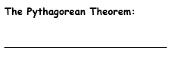 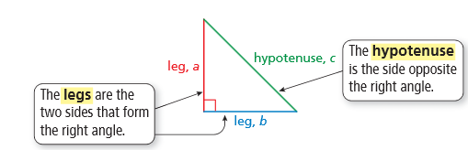

|  |
| --- |
| IMPORTANT: In order to use the Pythagorean Theorem formula, the triangle must be a ____________ triangle. |

FOR ADDITIONAL EXAMPLES ON FINDING THE HYPOTENUSE OF A RIGHT TRIANGLE, Watch Tutorial Video: **Section 7.3, Example 1**

|  |
| --- |
| **WARM UP:**  Find the length of the hypotenuse |

|  |
| --- |
| **EXAMPLE 3**  **Find the length of the missing side.** |

FOR ADDITIONAL EXAMPLES, watch Tutorial Video: **Section 7.3, Example 2;** then do the problems below.

|  |  |
| --- | --- |
| 1. Find the missing length of the triangle. | 1. Find the missing length of the triangle |

BACK 🡪

|  |
| --- |
| **Example 4:** Find the missing length of the figure.    **8 in**  **10 in** |
| **Example 5:** Find the perimeter of the figure. |
| 1. Find the missing length of the figure. |
| 1. Find the missing length of the figure. |