Name: __________________________ Table #: _______ Period: _______ Date:_________

**7.3B The Pythagorean Theorem_Classwork**

Objective: Apply the Pythagorean Theorem to determine unknown dsitances on triangles (CCSS: 8.G.8)

HW: (7.3B) p. 304 #3 – 12 (Solutions on p. A32) Copy down problem. Show your work. Check your solutions

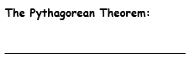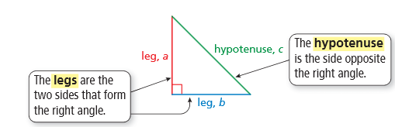

|  |
| --- |
| **EXAMPLE 1: Find the length of the hypothenuse of the triangle** |
| **EXAMPLE 2: Find the length of the hypotenuse.** |

FOR ADDITIONAL EXAMPLES, Watch Tutorial Video: **Section 7.3, Example 1**

|  |  |
| --- | --- |
| 1. Find the length of the hypotenuse of the triangle. | 2. Find the length of the hypotenuse of the triangle. |

|  |
| --- |
| **EXAMPLE 3**  **Find the length of the missing side.** |

FOR ADDITIONAL EXAMPLES, watch Tutorial Video: **Section 7.3, Example 2;** then do the problems below.

|  |  |
| --- | --- |
| 1. Find the missing length of the triangle. | 1. Find the missing length of the triangle. |

|  |
| --- |
| **Example 4:** Find the missing length of the figure.    **8 in**  **10 in** |
| **Example 5:** Find the missing length of the figure.    **x**  **10cm**  **15cm 6cm** |

|  |  |
| --- | --- |
| 1. Find the missing length of the figure. | 1. Find the missing length of the figure. |

**Warm Up**

|  |  |  |
| --- | --- | --- |
| 1. Simplify ${\left(\frac{3}{7}\right)}^{2}=$ | 2. Simplify ${\left(7\frac{2}{5}\right)}^{2}$ = | 3. Evaluate ${ \left(\sqrt[3]{64}\right)}^{3}-7^{2}=$ |

**CLASS SET. DO NOT WRITE ON. LEAVE FOR NEXT CLASS ☺**

**(7.3B) p. 304 #3 – 12**

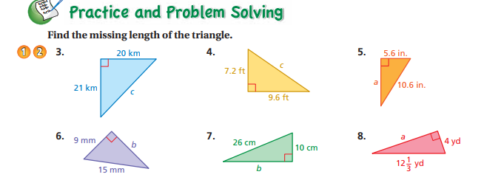

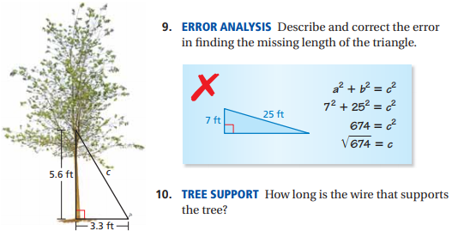

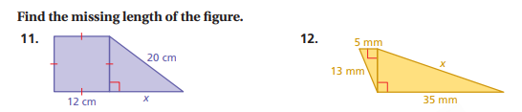

**Solutions on back**

**HW QUESTIONS**

