Name: __________________________ Table #: _____ Period: ____ Date:______
7.3B Triangles_Classwork
Objective: understand that the sum of the angle measures of any triangle is 180°; find missing angle measures in triangles. CC.SS.7.G.5
HW: 7.3B worksheet
WARM-UP
Find the value of x. Then classify the triangle.

EXAMPLE PROBLEMS
1.
2.
3.

PRACTICE PROBLEMS
1.  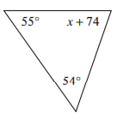  X = ________  Find the value of all three angles = ____________________________ | 2.  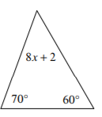  X = ________  Find the value of all three angles = ____________________________
3.  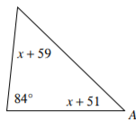  X = ________  Find the value of all three angles = ____________________________ | 4.  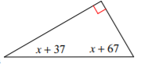  X = ________  Find the value of all three angles = ____________________________

