Name: ______________________ Table #: _________ Period: _____ Date: ______ 7.3B HW
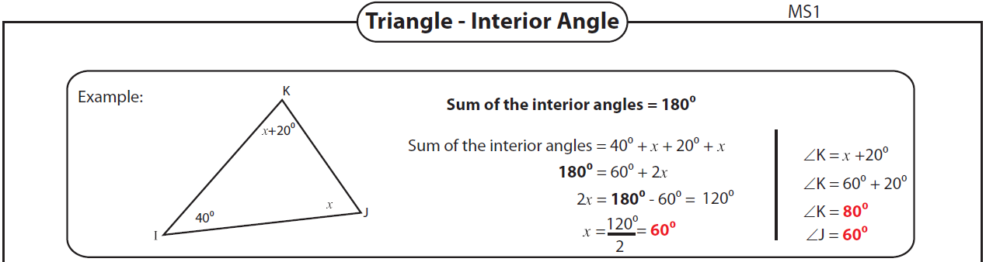
Find the value of x and unknown interior angles for each triangle.
