Name: ____________________ Table #: __________ Period: ______ Date: _______

7.3C NOTES – Pythagorean Theorem Word Problems

Objective: use Pythagorean Theorem to find missing side lengths of right triangles; solve real-life problems. CC.SS.8.EE.2/6/7/8 HW: 7.3C worksheet
WARM-UP
On Saturdays, I like to run to the park. There are two ways I can get there. From my house, (WAY 1) I can run 3 miles north and then turn left and 4 miles west OR (WAY 2) I can cut through a parking lot and run diagonally to the park, heading north-west. Which route should I take if I want to run the least? Which route should I take if I want to run the most? Explain how you know.

If I want to run the least, then I will take WAY ____.
If I want to run the most, then I will take WAY ____.
EXAMPLE 1
A 13feet ladder is placed 5 feet away from a wall. How far up the wall does the ladder go?

EXAMPLE 2
A softball diamond is a square with sides of 60 feet. What is the shortest distance between the first base and third base? Round to the nearest hundredth.

EXAMPLE 3
The rectangle has a length of 6 cm and a diagonal of 10 cm.
- What is the missing length of the rectangle? | - What is the area of the rectangle?

BACK
ON YOUR OWN
- The foot of a ladder is placed 6 feet from a wall. If the top of the ladder rests 8 feet up on the wall, how long is the ladder? | - John leaves school to go home. He walks 5 blocks north and then 12 blocks west. How far is John from the school, if he cuts through diagonally? | - The diagonal of a rectangle is 20 in. The width is 16 in. What is the area of the rectangle?

Similar Test Question to #18. (textbook pg 305 #17)_SNOWBALLS. You and your friend stand back-to-back. You run 20 feet forward, then 15 feet to your right. At the same time, your friend runs 16 feet forward, then 12 feet to her right. She stops and hits you with a snowball.
a) Draw the situation in a coordinate plane. b) How far does your friend throw the snowball?
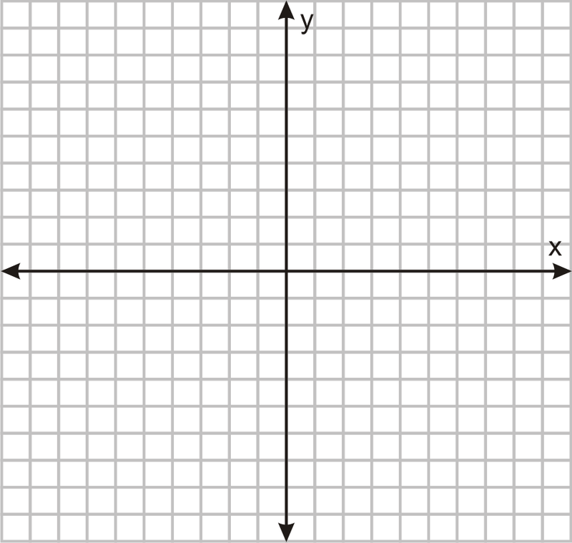 Your friend threw the snowball _______feet.

Similar Test Question #19. A surveyor holds a laser range finder 2 feet above the ground and determines that the range finder is 100 feet from a building and 110 feet from the top of the building. What is the height h of the building? Round your answer to the nearest tenth.
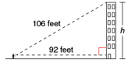

The building is about _________ feet tall.

