Name: __________________________ Table #: _______ Period: _______ Date:_________
7.3D Pythagorean Theorem Review Problems_Classwork
Objective: Apply the Pythagorean Theorem to real-life application(CCSS: 8.G.8)
HW: worksheet 7.3D HW

- Find the length of the hypotenuse of the triangle. Keep answer as a fraction.

$$\frac{8}{9}$$

$$\frac{2}{3}$$

- The volume V of a cylindrical can is represented by the formula $V=πr^{2}h$, where h is the height and r is the radius. A cylindrical can has a volume of $2250π$ cubic centimeters and a height of 10 centimeters. What is the radius of the can?

- Two groups of hikers leave the same camp heading in opposite directions. The first group travels 3 miles north and 5 miles east. The second group travels 2 miles south and 4 miles west.
- Draw the situation in the coordinate plane using a right triangle. Use the origin as the camp location, and let each unit represent 1 mile.
- Determine the distance between the two groups after the hikes. Round answer to the nearest tenth if necessary.

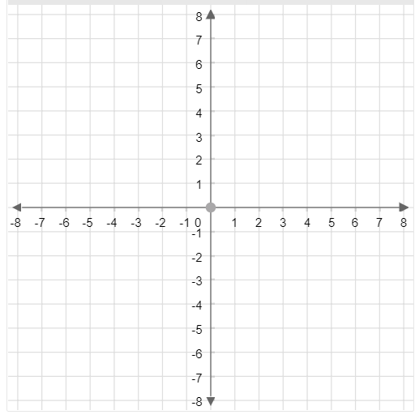
EXAMPLE PROBLEM: The base of a triangular prism is an isosceles right triangle with a hypotenuse of $\sqrt{288}$ centimeters. The height of the prism is 8 centimeters. Find the surface area of the triangular prism. Round your answer to the nearest tenth.
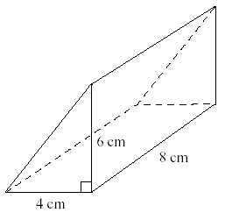

- The base of a triangular prism is an isosceles right triangle with a hypotenuse of $\sqrt{32}$ centimeters. The height of the prism is 7 centimeters. Find the surface area of the triangular prism. Round your answer to the nearest tenth.
