Name: __________________________ Table #: _______ Period: _______ Date:_________
7.3D HOMEWORK
Objective: Apply the Pythagorean Theorem to real-life application(CCSS: 8.G.8)

- Find the length of the hypotenuse of the triangle. Keep answer as a fraction.

1

$$\frac{3}{4}$$

- The volume V of a cylindrical can is represented by the formula $V=πr^{2}h$, where h is the height and r is the radius. A cylindrical can has a volume of $256π$ cubic centimeters and a height of 4 centimeters. What is the radius of the can?

- Two groups of hikers leave the same camp heading in opposite directions. The first group travels 2 miles north and 1 mile east. The second group travels 2 miles south and 2 miles west.
- Draw the situation in the coordinate plane using a right triangle. Use the origin as the camp location, and let each unit represent 1 mile.
- Determine the distance between the two groups after the hikes. Round answer to the nearest tenth if necessary.

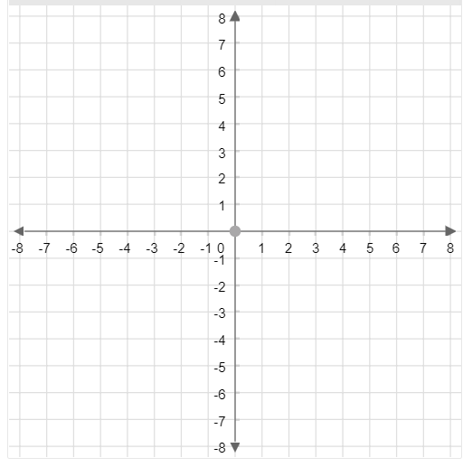
BACK
- The base of a triangular prism is an isosceles right triangle with a hypotenuse of $\sqrt{98}$ centimeters. The height of the prism is 4 centimeters. Find the surface area of the triangular prism. Round your answer to the nearest tenth.
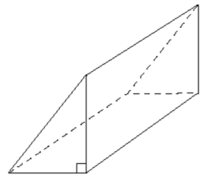

Solution: 1)$\frac{5}{4}$ 2)$8 cm$ 3)$5 miles$ 4) $144.6 {cm}^{2}$

