Name ________________________________________ Table# ____ Period: ______ Date:_____________

7.4A NOTES (Classifying Real Numbers)

Objective: define and identify real numbers; approximate square roots; compare real numbers. CC.SS.8.NS.1_MP1
HW: 7.4A Homework (handout)
#’s = numbers
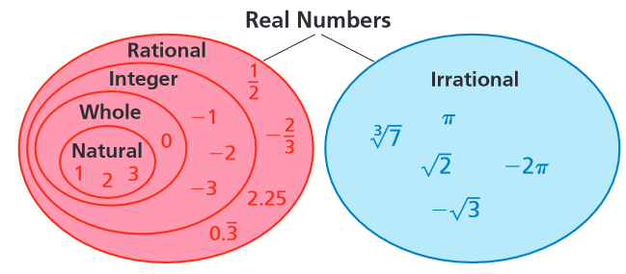
Words | Definitions and Examples
Real  Numbers | All _____________ & _______________ #’s
Rational #’s  Can be written as a fraction  $$\frac{integer}{integer } \frac{}{← ≠0}$$  *Terminating Decimals  *Repeating Decimals | All  _________________ #’s Ex’s:  _________________ #’s Ex’s:  _________________ Ex’s:  _________________ Ex’s:  SQUARE ROOTS OF __________ SQUARES  Ex’s:  CUBE ROOTS OF ___________ CUBES  Ex’s:  DECIMALS (terminating or repeating)  Decimals that __________ (terminate) Ex’s:  Decimals that ______________________ AND ______________ in a pattern  Ex’s:
Irrational #’s | Non-____________/ Non-______________ Decimals  Ex’s:  Square roots of #’s that are NOT _________________  Ex’s:  Cube roots of #’s that are NOT ___________________  Ex’s:

PRRACTICE PROBLEMS
Mark an X for each category that applies.
 | Number | Real | Rational | Irrational | Integer | Whole | Natural
1 | -6
2 | 0.593672…
3 | 0
4 | $$\frac{}{2}$$
5 | 2.393939…
6 | $$\frac{2}{5}$$
7 | $$\sqrt[3]{100}$$
8 | √25
9 | $$\sqrt{-1}$$
10 | 2.536

https://www.youtube.com/watch?v=vbPUS-0Wbv4
https://www.youtube.com/watch?v=_iE3iTOsE08
https://www.youtube.com/watch?v=0OwvN-957aE

