Name: ________________________ Table #: _________ Period: _______ Date:______
7.4A Quadrilateral_Classwork
Objective: understand that the sum of the angle measures of any quadrilateral is 360°; find missing angle measures in quadrilaterals; construct quadrilaterals. CC.SS.7.G.2
HW: 7.4A worksheet
RULE: Sum of the Angle Measures of a Quadrilateral
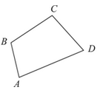

1.  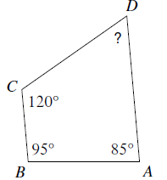  $$m∠D=_________$$ | 2.  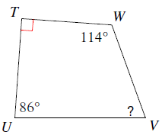  $$m∠V=_________$$
3.  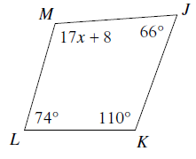  $$x=_________$$  $$m∠M=_________$$ | 4.  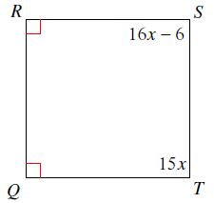  $$x=_________$$  $$m∠S=_________$$  $$m∠T=_________$$
WARM-UP: Solve for x and find all missing angles.
1.

2.

3.

